

Ανδρέας Λεβής (ΑΜ: 03119160)  
Μαρία-Λαμπρινή Μπαρτσιώκα (ΑΜ: 03119100)  
Χρυσούλα Πανηγυράκη (ΑΜ: 03119010)

**Databases Project**

**ΕΘΝΙΚΟ ΜΕΤΣΟΒΙΟ ΠΟΛΥΤΕΧΝΕΙΟ**

ΣΧΟΛΗ ΗΛΕΚΤΡΟΛΟΓΩΝ ΜΗΧΑΝΙΚΩΝ % ΜΗΧΑΝΙΚΩΝ ΥΠΟΛΟΓΙΣΤΩΝ

*ΤΟΜΕΑΣ ΠΛΗΡΟΦΟΡΙΚΗΣ*

Contents

I. Relational Diagram 2

II. Database in SQL 3

Tables 3

Other 7

DDL scripts 9

DML scripts 24

III. Organization of Files 54

IV. Prerequisites for Database and App Development 54

V. Steps for Installation 54

# Relational Diagram

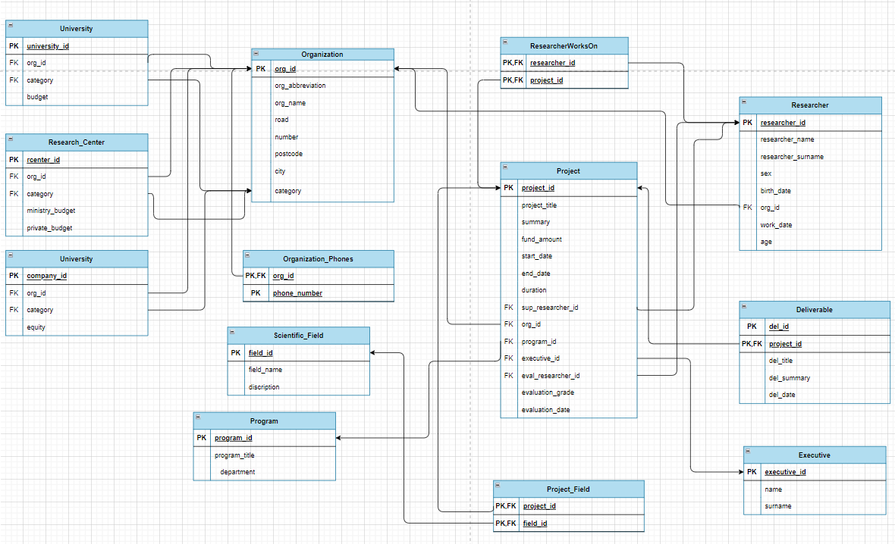

ER Diagram and Relational Diagram illustrate the logic within a database and how individual components relate to one another. Such diagrams lay out the wireframe of internal database structures to aid in understanding, improving efficiency, and debugging logical errors. The key pieces are the entities, attributes, and the relationships between them.

The above relational diagram describes the design of the database of a system which stores, manages and analyzes information for the Hellenic Foundation for Research and Innovation (ELIDEK). This database stores *organizations* (universities, research centers or companies) that manage *projects* and employ *researchers* to carry out these projects. The projects belong to a scientific *field*, while they are financed by ELIDEK *programs*, they have employees, *supervisors*, *evaluators* and *managers* and they may have individual *deliverables*. The necessary data for what was mentioned is stored in the database and the relationships between them are indicated in the diagram with arrows. The separation between entities of the same category is done mainly with the primary keys - IDs.

# Database in SQL

## Tables

The following is the design of the database in SQL language. The tables that are depicted in the relational diagram are created and their primary and foreign keys are defined, based on their importance and the relationships that connect the tables. As for the characteristics of the tables, they are set to NOT NULL when they are deemed necessary for the existence of each element of the respective table and are needed during its initialization. For this reason, the primary keys are always NOT NULL. As primary keys in each table are considered the IDs that are unique for each entity. Foreign keys are also set to NOT NULL, in order to be consistent with the primary keys of the relationships to which they belong.

* Organization

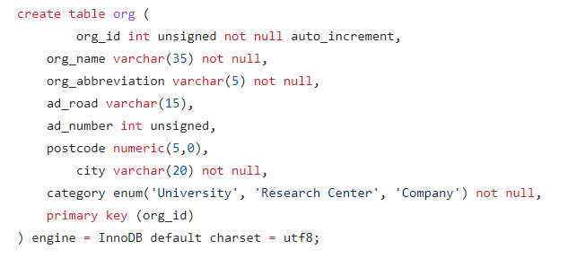

* Researcher

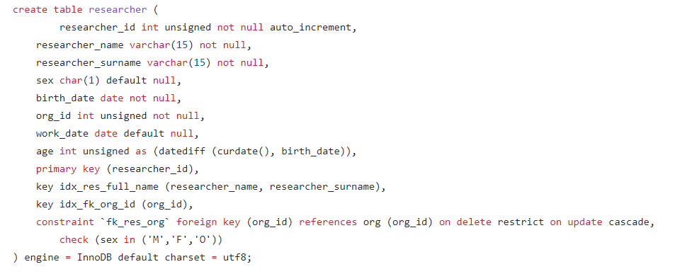

Attribute org_id is foreign key that matches in a relationship one organization to many researchers. An index res_full_name is also made to contain the name and suername of a researcher in one attribute.

* Executive

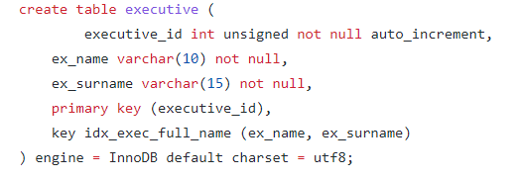

* Organization Phones

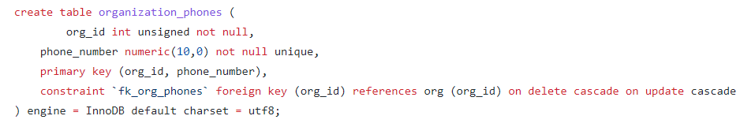

Attribute org_id is foreign key that matches in a relationship one organization to many phones.

* Scientific Field

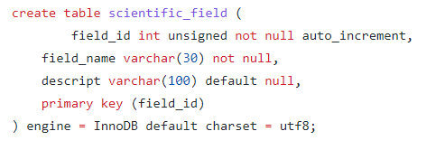

* Program

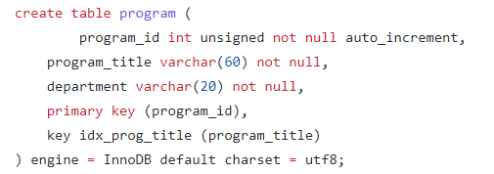

* Project

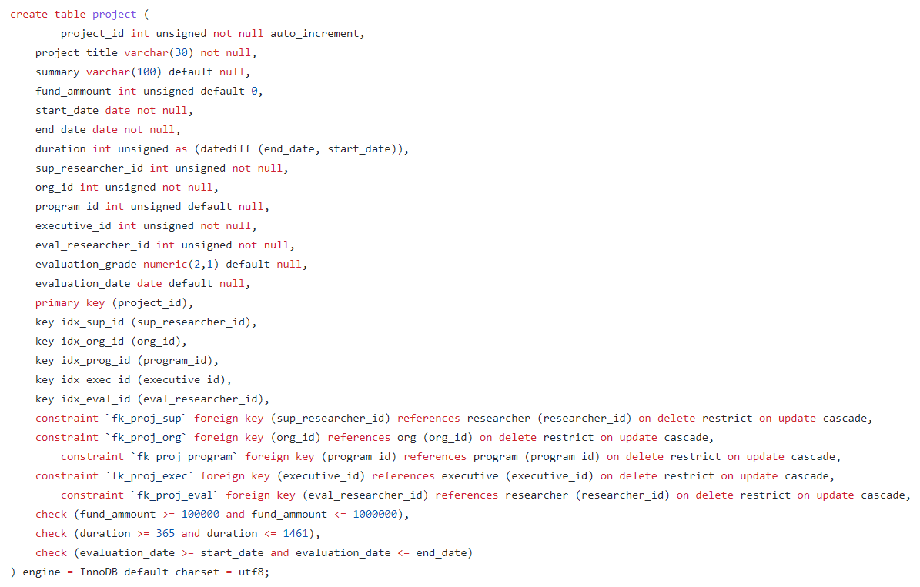

Attribute sup_researcher_id is foreign key that matches in a relationship one supervisor to one project. Attribute org_id is foreign key that matches in a relationship one organization to many projects. Attribute program_id is foreign key that matches in a relationship many projects to one program. Attribute executive_id is foreign key that matches in a relationship one executive to one project. Attribute eval_researcher_id is foreign key that matches in a relationship one evaluator to one project. In addition, the values of the fund amounts, the duration and the evaluation date of the projects are checked to be within the acceptable limits.

* Deliverable

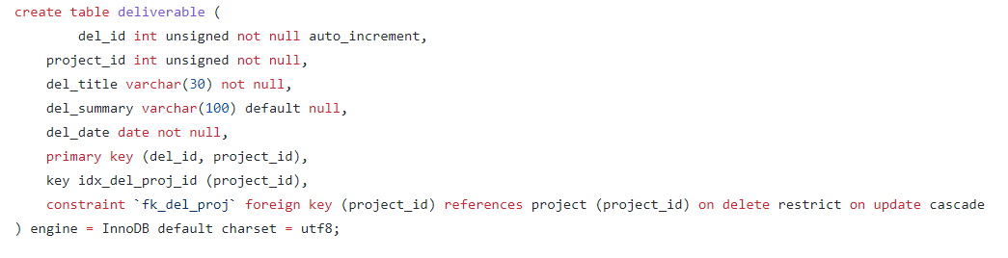

Attribute project_id is foreign key that matches in a relationship one project to many deliverables.

* Researcher Works On

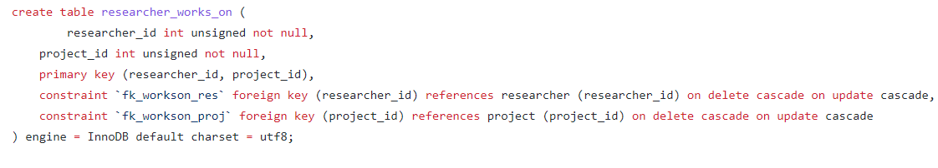

The above table demonstrates the relationship “works on” between researcher who works at a project and is has no specific role. Attributes researcher_id and project_id are foreign keys that matches in a relationship many researchers to one project.

* University

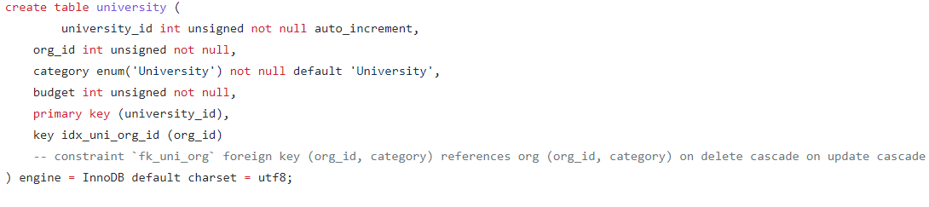

An organization can be either a University or a Research Center or a Company. So an index is created for foreign keys org_id and category in order to match in a relationship many universities to one organization. The tables for research center and company are created below in a same way.

* Research Center

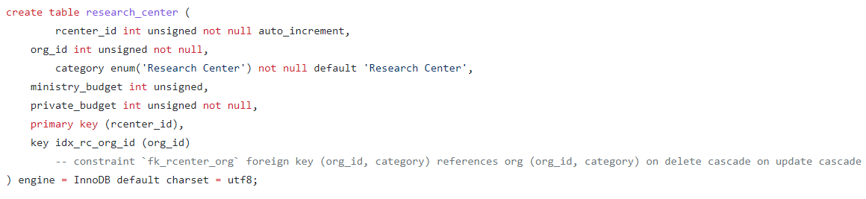

* Company

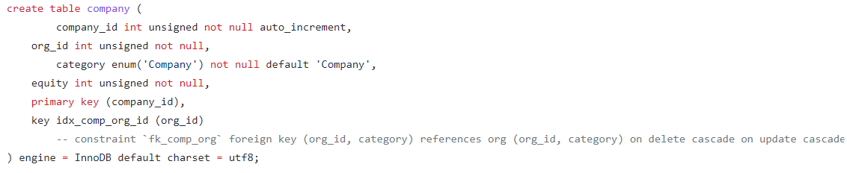

* Project Field

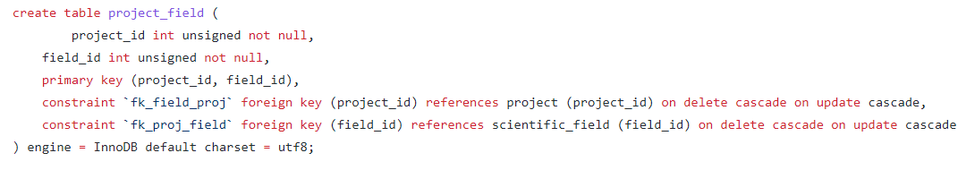

The above table demonstrates the relationship “belongs” between project which belongs to a scientific field. Attributes project_id and researcher_id are foreign keys that match in this relationship many projects to one field.

## Other

**Indexes** are defined for the attributes that are used the most so as to help queries run faster. All of them are obtained in the tables and have already been analyzed.

**Triggers** are stored procedures which automatically invokes whenever a special event occurs in the database and especially when a row is inserted or a column is being updated on a table. One of them is given as an example.

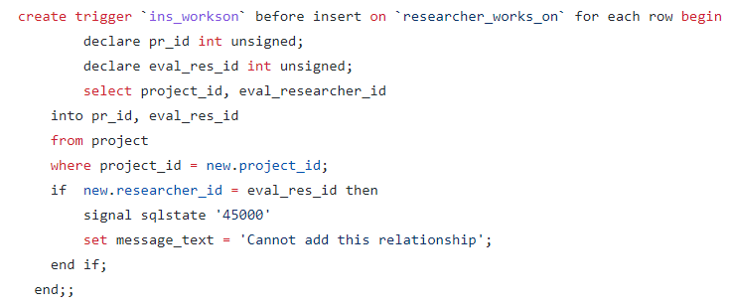

This trigger gives an error message if a new researcher who is entered in the table “researcher_works_on” has already been an evaluator for another project.

**Insert into** is a mandatory statement for every database in order to have values in its tables and to be able to run its queries. At first all the data are being deleted and then new data are inserted in the database. User can also add an insert into command to add individual entities.

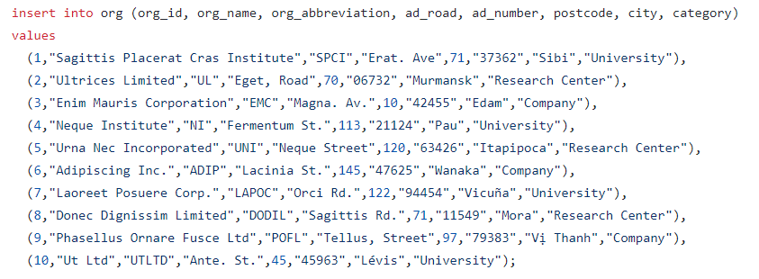

Data are inserted by rows accordingly to the attributes of each table, as it is shown above. In our implementation the database runs fake data generated from online app.

**Queries** request for data or information from a database table or combination of tables. Here queries implement the questions of the project. Queries are often combined with **Views**, that is virtual tables based on the result-set of an SQL query. A view contains rows and columns, just like a real table. The fields in a view are fields from one or more real tables in the database. For instance:

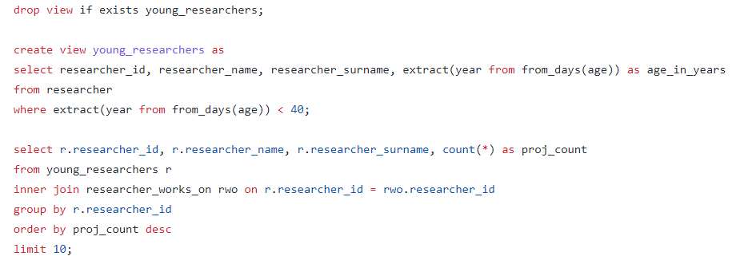

At the beginning of every view we have to delete objects from this view, that may be pre-existing, with drop command. For answering question 3.6 we created a view table which contains all the researchers (independently of their role) that are under 40 years old. Then, we created a query which selects from this view, joined with the relationship table “researcher_works_on”, the number of active projects that every researcher works on.

## DDL scripts

* Schema

set @old_unique_checks = @@unique_checks, unique_checks = 0;

set @old_foreign_key_checks = @@foreign_key_checks, foreign_key_checks = 0;

set @old_sql_mode = @@sql_mode, sql_mode = 'traditional';

drop schema if exists ELIDEK;

create schema ELIDEK;

use ELIDEK;

create table org (

org_id int unsigned not null auto_increment,

org_name varchar(35) not null,

org_abbreviation varchar(5) not null,

ad_road varchar(15),

ad_number int unsigned,

postcode numeric(5,0),

city varchar(20) not null,

category enum('University', 'Research Center', 'Company') not null,

primary key (org_id)

) engine = InnoDB default charset = utf8;

create index idx_org_cat on org (org_id, category);

create table researcher (

researcher_id int unsigned not null auto_increment,

researcher_name varchar(15) not null,

researcher_surname varchar(15) not null,

sex char(1) default null,

birth_date date not null,

org_id int unsigned not null,

work_date date default null,

age int unsigned as (datediff (curdate(), birth_date)),

primary key (researcher_id),

key idx_res_full_name (researcher_name, researcher_surname),

key idx_fk_org_id (org_id),

constraint `fk_res_org` foreign key (org_id) references org (org_id) on delete restrict on update cascade,

check (sex in ('M','F','O'))

) engine = InnoDB default charset = utf8;

create table executive (

executive_id int unsigned not null auto_increment,

ex_name varchar(10) not null,

ex_surname varchar(15) not null,

primary key (executive_id),

key idx_exec_full_name (ex_name, ex_surname)

) engine = InnoDB default charset = utf8;

create table organization_phones (

org_id int unsigned not null,

phone_number numeric(10,0) not null unique,

primary key (org_id, phone_number),

constraint `fk_org_phones` foreign key (org_id) references org (org_id) on delete cascade on update cascade

) engine = InnoDB default charset = utf8;

create table scientific_field (

field_id int unsigned not null auto_increment,

field_name varchar(30) not null,

descript varchar(100) default null,

primary key (field_id)

) engine = InnoDB default charset = utf8;

create table program (

program_id int unsigned not null auto_increment,

program_title varchar(60) not null,

department varchar(20) not null,

primary key (program_id),

key idx_prog_title (program_title)

) engine = InnoDB default charset = utf8;

create table project (

project_id int unsigned not null auto_increment,

project_title varchar(30) not null,

summary varchar(100) default null,

fund_ammount int unsigned default 0,

start_date date not null,

end_date date not null,

duration int unsigned as (datediff (end_date, start_date)),

sup_researcher_id int unsigned not null,

org_id int unsigned not null,

program_id int unsigned default null,

executive_id int unsigned not null,

eval_researcher_id int unsigned not null,

evaluation_grade numeric(2,1) default null,

evaluation_date date default null,

primary key (project_id),

key idx_sup_id (sup_researcher_id),

key idx_org_id (org_id),

key idx_prog_id (program_id),

key idx_exec_id (executive_id),

key idx_eval_id (eval_researcher_id),

constraint `fk_proj_sup` foreign key (sup_researcher_id) references researcher (researcher_id) on delete restrict on update cascade,

constraint `fk_proj_org` foreign key (org_id) references org (org_id) on delete restrict on update cascade,

constraint `fk_proj_program` foreign key (program_id) references program (program_id) on delete restrict on update cascade,

constraint `fk_proj_exec` foreign key (executive_id) references executive (executive_id) on delete restrict on update cascade,

constraint `fk_proj_eval` foreign key (eval_researcher_id) references researcher (researcher_id) on delete restrict on update cascade,

check (fund_ammount >= 100000 and fund_ammount <= 1000000),

check (duration >= 365 and duration <= 1461),

check (evaluation_date >= start_date and evaluation_date <= end_date)

) engine = InnoDB default charset = utf8;

create table deliverable (

del_id int unsigned not null auto_increment,

project_id int unsigned not null,

del_title varchar(30) not null,

del_summary varchar(100) default null,

del_date date not null,

primary key (del_id, project_id),

key idx_del_proj_id (project_id),

constraint `fk_del_proj` foreign key (project_id) references project (project_id) on delete restrict on update cascade

) engine = InnoDB default charset = utf8;

create table researcher_works_on (

researcher_id int unsigned not null,

project_id int unsigned not null,

primary key (researcher_id, project_id),

constraint `fk_workson_res` foreign key (researcher_id) references researcher (researcher_id) on delete cascade on update cascade,

constraint `fk_workson_proj` foreign key (project_id) references project (project_id) on delete cascade on update cascade

) engine = InnoDB default charset = utf8;

create table university (

university_id int unsigned not null auto_increment,

org_id int unsigned not null,

category enum('University') not null default 'University',

budget int unsigned not null,

primary key (university_id),

key idx_uni_org_id (org_id),

constraint `fk_uni_org` foreign key (org_id, category) references org (org_id, category) on delete cascade on update cascade

) engine = InnoDB default charset = utf8;

create table research_center (

rcenter_id int unsigned not null auto_increment,

org_id int unsigned not null,

category enum('Research Center') not null default 'Research Center',

ministry_budget int unsigned,

private_budget int unsigned not null,

primary key (rcenter_id),

key idx_rc_org_id (org_id),

constraint `fk_rcenter_org` foreign key (org_id, category) references org (org_id, category) on delete cascade on update cascade

) engine = InnoDB default charset = utf8;

create table company (

company_id int unsigned not null auto_increment,

org_id int unsigned not null,

category enum('Company') not null default 'Company',

equity int unsigned not null,

primary key (company_id),

key idx_comp_org_id (org_id),

constraint `fk_comp_org` foreign key (org_id, category) references org (org_id, category) on delete cascade on update cascade

) engine = InnoDB default charset = utf8;

create table project_field (

project_id int unsigned not null,

field_id int unsigned not null,

primary key (project_id, field_id),

constraint `fk_field_proj` foreign key (project_id) references project (project_id) on delete cascade on update cascade,

constraint `fk_proj_field` foreign key (field_id) references scientific_field (field_id) on delete cascade on update cascade

) engine = InnoDB default charset = utf8;

delimiter ;;

create trigger `ins_workson` before insert on `researcher_works_on` for each row begin

declare pr_id int unsigned;

declare eval_res_id int unsigned;

select project_id, eval_researcher_id

into pr_id, eval_res_id

from project

where project_id = new.project_id;

if new.researcher_id = eval_res_id then

signal sqlstate '45000'

set message_text = 'Cannot add this relationship';

end if;

end;;

create trigger `upd_workson` before update on `researcher_works_on` for each row begin

declare pr_id int unsigned;

declare eval_res_id int unsigned;

select project_id, eval_researcher_id

into pr_id, eval_res_id

from project

where project.project_id = new.project_id;

if new.researcher_id = eval_res_id then

signal sqlstate '45000'

set message_text = 'Cannot update this relationship';

end if;

end;;

create trigger `ins_workson2` before insert on `researcher_works_on` for each row begin

declare pr_id int unsigned;

declare or1_id int unsigned;

declare res_id int unsigned;

declare or2_id int unsigned;

select p.project_id, p.org_id, r.org_id, r.researcher_id

into pr_id, or1_id, or2_id, res_id

from project p, researcher r

where p.project_id = new.project_id and r.researcher_id = new.researcher_id;

if or1_id != or2_id then

signal sqlstate '45000'

set message_text = 'Cannot add this relationship';

end if;

end;;

create trigger `upd_workson2` before update on `researcher_works_on` for each row begin

declare pr_id int unsigned;

declare or1_id int unsigned;

declare res_id int unsigned;

declare or2_id int unsigned;

select p.project_id, p.org_id, r.org_id, r.researcher_id

into pr_id, or1_id, or2_id, res_id

from project p, researcher r

where p.project_id = new.project_id or r.researcher_id = new.researcher_id;

if or1_id != or2_id then

signal sqlstate '45000'

set message_text = 'Cannot add this relationship';

end if;

end;;

create trigger `ins_proj1` before insert on `project` for each row begin

if new.sup_researcher_id = new.eval_researcher_id then

signal sqlstate '45000'

set message_text = 'Cannot insert this project';

end if;

end;;

create trigger `upd_proj1` before update on `project` for each row begin

declare sup_res_id int unsigned;

declare eval_res_id int unsigned;

select sup_researcher_id, eval_researcher_id

into sup_res_id, eval_res_id

from project

where project.sup_researcher_id = new.sup_researcher_id or project.eval_researcher_id = new.eval_researcher_id;

if new.sup_researcher_id = eval_res_id or new.eval_researcher_id = sup_res_id then

signal sqlstate '45000'

set message_text = 'Cannot update this project';

end if;

end;;

create trigger `ins_proj2` before insert on `project` for each row begin

if new.end_date < new.start_date then

signal sqlstate '45000'

set message_text = 'Cannot insert this project';

end if;

end;;

/* Check if the evaluator added does not work on the organization specified in org_id */

create trigger `ins_eval` before insert on `project` for each row begin

declare res_id int unsigned;

declare or_id int unsigned;

select researcher.researcher_id, researcher.org_id

into res_id, or_id

from researcher

where new.eval_researcher_id = researcher.researcher_id;

if new.org_id = or_id then

signal sqlstate '45000'

set message_text = 'Cannot add this project due to the evaluator';

end if;

end;;

create trigger `upd_eval` before update on `project` for each row begin

declare or1_id int unsigned;

declare eval_res_id int unsigned;

declare res_id int unsigned;

declare or2_id int unsigned;

select project.org_id, project.eval_researcher_id, researcher.researcher_id, researcher.org_id

into or1_id, eval_res_id, res_id, or2_id

from project join researcher

where project.eval_researcher_id = new.eval_researcher_id and new.eval_researcher_id = researcher.researcher_id;

if or1_id = or2_id then

signal sqlstate '45000'

set message_text = 'Cannot update this project';

end if;

end;;

create trigger `ins_del_date` before insert on `deliverable` for each row begin

declare st_date date;

declare en_date date;

declare pr1_id int unsigned;

select p.start_date, p.end_date, p.project_id

into st_date, en_date, pr1_id

from project p

where p.project_id = new.project_id;

if new.del_date < st_date or new.del_date > en_date then

signal sqlstate '45000'

set message_text = 'Cannot insert this deliverable';

end if;

end;;

create trigger `upd_del_date` before update on `deliverable` for each row begin

declare st_date date;

declare pr1_id int unsigned;

declare pr2_id int unsigned;

select p.start_date, p.project_id, d.project_id

into st_date, pr1_id, pr2_id

from project p, deliverable d

where d.project_id = new.project_id and new.project_id = p.project_id;

if new.del_date < st_date then

signal sqlstate '45000'

set message_text = 'Cannot update this deliverable';

end if;

end;;

delimiter ;

set sql_mode=@old_sql_mode;

set foreign_key_checks=@old_foreign_key_checks;

set unique_checks=@old_unique_checks;

* Queries

use ELIDEK;

drop view if exists active_projects;

create view active_projects as

select project_id, project_title, fund_ammount

from project

where start_date <= curdate() and end_date > curdate();

-- 3.1 ok

-- data x,a,d given by user

drop view if exists proj;

create view proj as

select p.project_id, p.project_title, rwo.researcher_id, r.researcher_name, r.researcher_surname

from project p

inner join researcher_works_on rwo on rwo.project_id = p.project_id

inner join researcher r on r.researcher_id = rwo.researcher_id

where p.project_id = x or p.executive_id = a or year(p.start_date) = d or (p.duration > 1 and p.duration < 2) or (p.duration > 2 and p.duration < 3) or (p.duration > 3 and p.duration < 4) ;

-- 3.2 ok

-- researcher_id x given by user

drop view if exists projects_per_res;

create view projects_per_res as

select p.project_id, p.project_title, p.fund_ammount

from active_projects p

inner join researcher_works_on rwo on p.project_id = rwo.project_id

where rwo.researcher_id = x;

-- org_id y given by user

drop view if exists programs_per_org;

create view programs_per_org as

select p.program_id, p.program_title, p.department

from program p

inner join project r on r.program_id = p.program_id

inner join org o on o.org_id = r.org_id

where r.org_id = y;

-- 3.3 ok

-- field_id f given by user

drop view if exists projects_in_field_f;

create view projects_in_field_f as

select p.project_id, p.project_title from active_projects p

inner join project_field pf on p.project_id = pf.project_id

where pf.field_id = f and p.fund_ammount >= 0;

drop view if exists researchers_in_field_f;

create view researchers_in_field_f as

select r.researcher_id, r.researcher_name, r.researcher_surname from researcher r

inner join researcher_works_on rwo on r.researcher_id = rwo.researcher_id

inner join active_projects p on p.project_id = rwo.project_id

inner join project_field pf on p.project_id = pf.project_id

where pf.field_id = f;

-- 3.4 ok

drop view if exists annual_proj;

create view annual_proj as

select o.org_id, o.org_name, count(*) as projects, year(p.start_date) as dates

from org o

inner join project p on o.org_id = p.org_id

group by org_id, year(p.start_date);

select a.org_id, a.org_name, a.projects, b.projects

from annual_proj a, annual_proj b

where a.org_id = b.org_id and a.dates = b.dates + 1

having a.projects = b.projects and a.projects >= 10;

-- 3.5 ok

drop view if exists field_tuple;

create view field_tuple as

select p1.field_id as field1, p2.field_id as field2, p1.project_id

from project_field p1, project_field p2

where p1.project_id = p2.project_id and p1.field_id <> p2.field_id;

select s1.field_name as scientific_field1, t.field1 as id1, s2.field_name as scientific_field2, t.field2 as id2, count(*) as tuple_count

from field_tuple t

inner join scientific_field s1 on s1.field_id = t.field1

inner join scientific_field s2 on s2.field_id = t.field2

inner join project_field p1 on p1.field_id = t.field1 and p1.project_id = t.project_id

inner join project_field p2 on p2.field_id = t.field2 and p1.project_id = p2.project_id

group by t.field1, t.field2

order by tuple_count desc

limit 3;

-- 3.6 ok

drop view if exists young_researchers;

create view young_researchers as

select researcher_id, researcher_name, researcher_surname, extract(year from from_days(age)) as age_in_years

from researcher

where extract(year from from_days(age)) < 40;

select r.researcher_id, r.researcher_name, r.researcher_surname, count(*) as proj_count

from young_researchers r

inner join researcher_works_on rwo on r.researcher_id = rwo.researcher_id

inner join active_projects a on a.project_id = rwo.project_id

group by r.researcher_id

order by proj_count desc

limit 10;

-- 3.7 ok

drop view if exists top_5;

create view top_5 as

select concat(e.ex_surname, ' ', e.ex_name) exec_full_name, o.org_name, sum(fund_ammount) as total_fund

from project p

inner join org o on p.org_id = o.org_id

inner join executive e on e.executive_id = p.executive_id

where o.category = 'Company'

group by exec_full_name, o.org_name

order by total_fund desc

limit 5;

-- 3.8 ok

drop view if exists no_del;

create view no_del as

select p.project_id from project p

where not exists (select d.del_id from deliverable d where p.project_id = d.project_id);

drop view if exists no_del_per_res;

create view no_del_per_res as

select r.researcher_id, r.researcher_name, r.researcher_surname, count(*) as proj_count

from researcher r

inner join researcher_works_on rwo on rwo.researcher_id = r.researcher_id

inner join no_del p on p.project_id = rwo.project_id

group by researcher_id;

select * from no_del_per_res where proj_count >= 5;

## DML scripts

* Insert

use ELIDEK;

delete from deliverable;

delete from project;

delete from researcher_works_on;

delete from project_field;

delete from program;

delete from executive;

delete from scientific_field;

delete from organization_phones;

delete from researcher;

delete from org;

delete from university;

delete from research_center;

delete from company;

insert into org (org_id, org_name, org_abbreviation, ad_road, ad_number, postcode, city, category)

values

(1,"Sagittis Placerat Cras Institute","SPCI","Erat. Ave",71,"37362","Sibi","University"),

(2,"Ultrices Limited","UL","Eget, Road",70,"06732","Murmansk","Research Center"),

(3,"Enim Mauris Corporation","EMC","Magna. Av.",10,"42455","Edam","Company"),

(4,"Neque Institute","NI","Fermentum St.",113,"21124","Pau","University"),

(5,"Urna Nec Incorporated","UNI","Neque Street",120,"63426","Itapipoca","Research Center"),

(6,"Adipiscing Inc.","ADIP","Lacinia St.",145,"47625","Wanaka","Company"),

(7,"Laoreet Posuere Corp.","LAPOC","Orci Rd.",122,"94454","Vicuña","University"),

(8,"Donec Dignissim Limited","DODIL","Sagittis Rd.",71,"11549","Mora","Research Center"),

(9,"Phasellus Ornare Fusce Ltd","POFL","Tellus, Street",97,"79383","Vị Thanh","Company"),

(10,"Ut Ltd","UTLTD","Ante. St.",45,"45963","Lévis","University");

insert into org (org_id, org_name, org_abbreviation, ad_road, ad_number, postcode, city, category)

values

(11,"Ac Feugiat Non Incorporated","ACFNI","In Street",72,"31823","Hammerfest","Research Center"),

(12,"Ornare In Faucibus Foundation","OINFF","Egestas Ave",132,"49241","Daknam","Company"),

(13,"Duis A Mi Company","DUAMI","Risus St.",125,"46133","Sungei Kadut","University"),

(14,"Arcu Aliquam Ultrices Incorporated","AAUI","Ac St.",52,"22135","Norman Wells","Research Center"),

(15,"Venenatis Lacus Etiam PC","VLEPC","Tellus St.",117,"75855","Cambridge Bay","Company"),

(16,"Dictum Eleifend Nunc LLP","DIEN","Amet Road",87,"62574","Warrnambool","University"),

(17,"Aenean Euismod Mauris LLP","AEM","Ac Rd.",129,"62679","Arequipa","Research Center"),

(18,"Egestas Rhoncus Industries","ERI","Sit Ave",66,"16673","Allentown","Company"),

(19,"Nam Corporation","NAMCO","Vel, Street",60,"57254","Jammu","University"),

(20,"Molestie Sodales Corp.","MOSCO","Purus. Rd.",126,"74513","Berlin","Research Center");

insert into org (org_id, org_name, org_abbreviation, ad_road, ad_number, postcode, city, category)

values

(21,"Et Industries","ETIN","Magna. St.",149,"11111","Rangiora","Company"),

(22,"Luctus Et Inc.","LUCET","Hendrerit Av.",59,"57932","Port Harcourt","University"),

(23,"Diam At Industries","DIAI","Nisl Rd.",149,"23641","Okigwe","Research Center"),

(24,"Erat Associates","ERATA","Non Rd.",137,"64115","Bregenz","Company"),

(25,"Adipiscing Fringilla Limited","AFL","Donec St.",34,"58282","Picton","University"),

(26,"Quisque Company","QUCO","Proin Av.",45,"64413","Salem","Research Center"),

(27,"Tincidunt Pede PC","TIPE","Amet Rd.",142,"84338","Grasse","Company"),

(28,"Orci Luctus Et LLC","ORLU","Quis Street",90,"14380","Mo i Rana","University"),

(29,"Urna Justo Ltd","UJU","Ultricies St.",105,"52032","Meppel","Research Center"),

(30,"Nec Eleifend Inc.","NEI","Mollis Av.",54,"27295","Tynda","Company");

insert into researcher (researcher_id, researcher_name, researcher_surname, sex, birth_date, org_id, work_date) values (1, 'Vick', 'Worts', 'M', '1980-12-05', 1, '2021-02-13');

insert into researcher (researcher_id, researcher_name, researcher_surname, sex, birth_date, org_id, work_date) values (2, 'Sibylle', 'Quantrill', 'F', '1991-12-20', 3, '2017-10-18');

insert into researcher (researcher_id, researcher_name, researcher_surname, sex, birth_date, org_id, work_date) values (3, 'Marnia', 'Linnard', 'F', '1991-11-03', 5,'2018-10-08');

insert into researcher (researcher_id, researcher_name, researcher_surname, sex, birth_date, org_id, work_date) values (4, 'Jamima', 'Skudder', 'F', '1981-05-09', 7, '2013-01-06');

insert into researcher (researcher_id, researcher_name, researcher_surname, sex, birth_date, org_id, work_date) values (5, 'Demott', 'Bird', 'M', '1989-01-17', 9, '2019-08-26');

insert into researcher (researcher_id, researcher_name, researcher_surname, sex, birth_date, org_id, work_date) values (6, 'Fanchette', 'Boyington', 'F', '1977-03-04', 11, '2020-10-21');

insert into researcher (researcher_id, researcher_name, researcher_surname, sex, birth_date, org_id, work_date) values (7, 'Ravi', 'Hucknall', 'M', '1968-06-10', 13, '2006-04-21');

insert into researcher (researcher_id, researcher_name, researcher_surname, sex, birth_date, org_id, work_date) values (8, 'Adey', 'Tretter', 'F', '1985-07-16', 15, '2004-07-29');

insert into researcher (researcher_id, researcher_name, researcher_surname, sex, birth_date, org_id, work_date) values (9, 'Kennie', 'Mizzen', 'M', '1997-10-14', 17, '2008-12-29');

insert into researcher (researcher_id, researcher_name, researcher_surname, sex, birth_date, org_id, work_date) values (10, 'Ber', 'Brucker', 'M', '1972-10-06', 19, '2002-11-27');

insert into researcher (researcher_id, researcher_name, researcher_surname, sex, birth_date, org_id, work_date) values (11, 'Grethel', 'Chape', 'O', '1996-10-19', 21, '2014-08-28');

insert into researcher (researcher_id, researcher_name, researcher_surname, sex, birth_date, org_id, work_date) values (12, 'Hewet', 'Sparkwell', 'M', '1968-05-09', 23, '2019-01-11');

insert into researcher (researcher_id, researcher_name, researcher_surname, sex, birth_date, org_id, work_date) values (13, 'Cozmo', 'Iiannoni', 'M', '1996-08-04', 25, '2020-12-17');

insert into researcher (researcher_id, researcher_name, researcher_surname, sex, birth_date, org_id, work_date) values (14, 'Emelda', 'Paolone', 'F', '1993-08-29', 27, '2019-08-07');

insert into researcher (researcher_id, researcher_name, researcher_surname, sex, birth_date, org_id, work_date) values (15, 'Gui', 'Matzke', 'F', '1967-11-26', 29, '2020-11-02');

insert into researcher (researcher_id, researcher_name, researcher_surname, sex, birth_date, org_id, work_date) values (16, 'Ardine', 'Shilburne', 'F', '1975-10-05', 7, '2008-04-27');

insert into researcher (researcher_id, researcher_name, researcher_surname, sex, birth_date, org_id, work_date) values (17, 'Sadye', 'Heatly', 'O', '1992-06-22', 10, '2009-01-12');

insert into researcher (researcher_id, researcher_name, researcher_surname, sex, birth_date, org_id, work_date) values (18, 'Keary', 'Sabban', 'M', '1979-09-15', 14, '2011-06-11');

insert into researcher (researcher_id, researcher_name, researcher_surname, sex, birth_date, org_id, work_date) values (19, 'Hedvig', 'Dabell', 'F', '1998-12-12', 18, '2018-09-26');

insert into researcher (researcher_id, researcher_name, researcher_surname, sex, birth_date, org_id, work_date) values (20, 'Janelle', 'Purton', 'F', '1969-01-23', 20, '2003-01-23');

insert into researcher (researcher_id, researcher_name, researcher_surname, sex, birth_date, org_id, work_date) values (21, 'Jacqui', 'Iohananof', 'F', '1999-03-15', 21, '2015-04-24');

insert into researcher (researcher_id, researcher_name, researcher_surname, sex, birth_date, org_id, work_date) values (22, 'Obie', 'Madgin', 'M', '1968-12-28', 4, '2012-08-16');

insert into researcher (researcher_id, researcher_name, researcher_surname, sex, birth_date, org_id, work_date) values (23, 'Dmitri', 'Millea', 'M', '1998-08-14', 9, '2008-12-18');

insert into researcher (researcher_id, researcher_name, researcher_surname, sex, birth_date, org_id, work_date) values (24, 'Osmond', 'Wake', 'M', '1968-02-25', 26, '2019-03-07');

insert into researcher (researcher_id, researcher_name, researcher_surname, sex, birth_date, org_id, work_date) values (25, 'Nanni', 'Howland', 'F', '1966-11-08', 24, '2016-08-18');

insert into researcher (researcher_id, researcher_name, researcher_surname, sex, birth_date, org_id, work_date) values (26, 'Lamar', 'Hitchens', 'M', '1966-10-27', 29, '2019-04-01');

insert into researcher (researcher_id, researcher_name, researcher_surname, sex, birth_date, org_id, work_date) values (27, 'Erna', 'Gillbanks', 'F', '1972-05-13', 30, '2003-02-05');

insert into researcher (researcher_id, researcher_name, researcher_surname, sex, birth_date, org_id, work_date) values (28, 'Noel', 'Dilland', 'F', '1988-06-12', 17, '2016-03-04');

insert into researcher (researcher_id, researcher_name, researcher_surname, sex, birth_date, org_id, work_date) values (29, 'Kennan', 'Dellenbach', 'M', '1972-04-04', 16, '2014-12-19');

insert into researcher (researcher_id, researcher_name, researcher_surname, sex, birth_date, org_id, work_date) values (30, 'Danny', 'Kestle', 'M', '1994-09-23', 6, '2002-08-10');

insert into researcher (researcher_id, researcher_name, researcher_surname, sex, birth_date, org_id, work_date) values (31, 'Elise', 'Lawrence', 'F', '1983-10-26', 12, '2016-08-10');

insert into researcher (researcher_id, researcher_name, researcher_surname, sex, birth_date, org_id, work_date) values (32, 'Tabby', 'Dammarell', 'F', '1972-03-28', 13, '2003-02-19');

insert into researcher (researcher_id, researcher_name, researcher_surname, sex, birth_date, org_id, work_date) values (33, 'Ruthie', 'Lowth', 'F', '1966-08-07', 5, '2009-01-29');

insert into researcher (researcher_id, researcher_name, researcher_surname, sex, birth_date, org_id, work_date) values (34, 'Karrie', 'Speeks', 'F', '1985-07-02', 8, '2016-02-15');

insert into researcher (researcher_id, researcher_name, researcher_surname, sex, birth_date, org_id, work_date) values (35, 'Ezekiel', 'Maddigan', 'M', '1983-06-10', 22, '2012-11-21');

insert into researcher (researcher_id, researcher_name, researcher_surname, sex, birth_date, org_id, work_date) values (36, 'Charmane', 'Kirkwood', 'F', '1980-09-08', 23, '2013-05-02');

insert into researcher (researcher_id, researcher_name, researcher_surname, sex, birth_date, org_id, work_date) values (37, 'Clayson', 'Aronsohn', 'M', '1983-03-29', 26, '2017-12-10');

insert into researcher (researcher_id, researcher_name, researcher_surname, sex, birth_date, org_id, work_date) values (38, 'Karena', 'Waine', 'F', '1998-08-29', 11, '2007-09-23');

insert into researcher (researcher_id, researcher_name, researcher_surname, sex, birth_date, org_id, work_date) values (39, 'Lorry', 'Webb-Bowen', 'M', '1992-07-23', 2, '2016-04-21');

insert into researcher (researcher_id, researcher_name, researcher_surname, sex, birth_date, org_id, work_date) values (40, 'Gertruda', 'Giacobo', 'F', '1974-05-17', 3, '2005-02-25');

insert into researcher (researcher_id, researcher_name, researcher_surname, sex, birth_date, org_id, work_date) values (41, 'Tracie', 'Devanney', 'F', '1972-09-06', 28, '2009-04-23');

insert into researcher (researcher_id, researcher_name, researcher_surname, sex, birth_date, org_id, work_date) values (42, 'Darill', 'Indruch', 'M', '1978-06-03', 27, '2009-06-28');

insert into researcher (researcher_id, researcher_name, researcher_surname, sex, birth_date, org_id, work_date) values (43, 'Bunni', 'Breitler', 'F', '1976-08-28', 25, '2017-09-10');

insert into researcher (researcher_id, researcher_name, researcher_surname, sex, birth_date, org_id, work_date) values (44, 'Tanny', 'Carah', 'M', '1995-09-14', 20, '2016-01-04');

insert into researcher (researcher_id, researcher_name, researcher_surname, sex, birth_date, org_id, work_date) values (45, 'Glad', 'Somerlie', 'F', '1965-06-22', 16, '2015-12-28');

insert into researcher (researcher_id, researcher_name, researcher_surname, sex, birth_date, org_id, work_date) values (46, 'Giustina', 'Reily', 'M', '1971-03-06', 15, '2020-10-15');

insert into researcher (researcher_id, researcher_name, researcher_surname, sex, birth_date, org_id, work_date) values (47, 'Odilia', 'Greenstock', 'F', '1971-04-27', 2, '2011-01-20');

insert into researcher (researcher_id, researcher_name, researcher_surname, sex, birth_date, org_id, work_date) values (48, 'Bryanty', 'Fakes', 'M', '1993-02-12', 1, '2012-04-08');

insert into researcher (researcher_id, researcher_name, researcher_surname, sex, birth_date, org_id, work_date) values (49, 'Celestyn', 'Dallimare', 'F', '1973-08-07', 6, '2016-03-21');

insert into researcher (researcher_id, researcher_name, researcher_surname, sex, birth_date, org_id, work_date) values (50, 'Delainey', 'Wane', 'O', '1991-11-05', 9, '2019-03-24');

insert into researcher (researcher_id, researcher_name, researcher_surname, sex, birth_date, org_id, work_date) values (51, 'Everard', 'de Almeida', 'O', '1980-08-01', 24, '2007-05-20');

insert into researcher (researcher_id, researcher_name, researcher_surname, sex, birth_date, org_id, work_date) values (52, 'Mal', 'Ker', 'O', '2001-04-12', 29, '2008-11-17');

insert into researcher (researcher_id, researcher_name, researcher_surname, sex, birth_date, org_id, work_date) values (53, 'Maurene', 'Glede', 'F', '1971-03-25', 20, '2016-10-10');

insert into researcher (researcher_id, researcher_name, researcher_surname, sex, birth_date, org_id, work_date) values (54, 'Raviv', 'Hurler', 'M', '1974-01-27', 18, '2013-10-24');

insert into researcher (researcher_id, researcher_name, researcher_surname, sex, birth_date, org_id, work_date) values (55, 'Brendin', 'Martinelli', 'M', '1988-05-31', 30, '2002-08-05');

insert into researcher (researcher_id, researcher_name, researcher_surname, sex, birth_date, org_id, work_date) values (56, 'Liliane', 'Tackell', 'F', '1988-08-31', 4, '2007-09-13');

insert into researcher (researcher_id, researcher_name, researcher_surname, sex, birth_date, org_id, work_date) values (57, 'Gerrie', 'Loghan', 'O', '1977-08-29', 8, '2009-05-22');

insert into researcher (researcher_id, researcher_name, researcher_surname, sex, birth_date, org_id, work_date) values (58, 'Binni', 'Ledrun', 'F', '1990-09-10', 6, '2017-01-17');

insert into researcher (researcher_id, researcher_name, researcher_surname, sex, birth_date, org_id, work_date) values (59, 'Frank', 'Vernalls', 'M', '1979-04-04', 1, '2009-05-08');

insert into researcher (researcher_id, researcher_name, researcher_surname, sex, birth_date, org_id, work_date) values (60, 'Bronnie', 'Neild', 'M', '1970-09-11', 22, '2018-02-08');

insert into researcher (researcher_id, researcher_name, researcher_surname, sex, birth_date, org_id, work_date) values (61, 'Libbey', 'Rothera', 'F', '1979-07-02', 23, '2012-01-02');

insert into researcher (researcher_id, researcher_name, researcher_surname, sex, birth_date, org_id, work_date) values (62, 'Ulla', 'Goodhand', 'F', '1977-05-08', 14, '2019-11-23');

insert into researcher (researcher_id, researcher_name, researcher_surname, sex, birth_date, org_id, work_date) values (63, 'Sharai', 'Mundy', 'F', '1983-03-09', 10, '2010-11-08');

insert into researcher (researcher_id, researcher_name, researcher_surname, sex, birth_date, org_id, work_date) values (64, 'Wilfrid', 'Fraczak', 'M', '1986-03-30', 25, '2019-01-09');

insert into researcher (researcher_id, researcher_name, researcher_surname, sex, birth_date, org_id, work_date) values (65, 'Olivie', 'Parsonage', 'F', '1988-01-17', 19, '2020-03-30');

insert into researcher (researcher_id, researcher_name, researcher_surname, sex, birth_date, org_id, work_date) values (66, 'Charlton', 'Mead', 'M', '2001-03-13', 15, '2008-03-07');

insert into researcher (researcher_id, researcher_name, researcher_surname, sex, birth_date, org_id, work_date) values (67, 'Alaster', 'Furney', 'M', '1990-12-04', 28, '2014-09-07');

insert into researcher (researcher_id, researcher_name, researcher_surname, sex, birth_date, org_id, work_date) values (68, 'Bax', 'Cardo', 'M', '1995-05-14', 7, '2002-10-14');

insert into researcher (researcher_id, researcher_name, researcher_surname, sex, birth_date, org_id, work_date) values (69, 'Everard', 'Cowdrey', 'M', '1976-05-04', 25, '2006-12-31');

insert into researcher (researcher_id, researcher_name, researcher_surname, sex, birth_date, org_id, work_date) values (70, 'Missie', 'Bouskill', 'F', '1978-01-01', 24, '2016-10-11');

insert into researcher (researcher_id, researcher_name, researcher_surname, sex, birth_date, org_id, work_date) values (71, 'Lurleen', 'McCobb', 'O', '1971-10-18', 28, '2011-04-08');

insert into researcher (researcher_id, researcher_name, researcher_surname, sex, birth_date, org_id, work_date) values (72, 'Sybila', 'Haville', 'F', '1989-09-21', 30, '2009-06-02');

insert into researcher (researcher_id, researcher_name, researcher_surname, sex, birth_date, org_id, work_date) values (73, 'Johnathan', 'Pollitt', 'M', '1995-12-23', 27, '2003-04-15');

insert into researcher (researcher_id, researcher_name, researcher_surname, sex, birth_date, org_id, work_date) values (74, 'Antone', 'Jedrzejczak', 'M', '1990-07-01', 5, '2005-11-01');

insert into researcher (researcher_id, researcher_name, researcher_surname, sex, birth_date, org_id, work_date) values (75, 'Ingrim', 'Peyes', 'M', '1971-12-27', 2, '2020-06-03');

insert into researcher (researcher_id, researcher_name, researcher_surname, sex, birth_date, org_id, work_date) values (76, 'Ari', 'Hamberston', 'M', '1989-04-06', 12, '2013-11-04');

insert into researcher (researcher_id, researcher_name, researcher_surname, sex, birth_date, org_id, work_date) values (77, 'Robers', 'Pearman', 'M', '1972-02-09', 10, '2007-11-26');

insert into researcher (researcher_id, researcher_name, researcher_surname, sex, birth_date, org_id, work_date) values (78, 'Hallie', 'Ladbrook', 'F', '1993-08-10', 3, '2015-11-28');

insert into researcher (researcher_id, researcher_name, researcher_surname, sex, birth_date, org_id, work_date) values (79, 'Westbrooke', 'Gavin', 'M', '1981-05-19', 5, '2016-09-08');

insert into researcher (researcher_id, researcher_name, researcher_surname, sex, birth_date, org_id, work_date) values (80, 'Hogan', 'Letch', 'O', '1986-09-23', 6, '2017-09-09');

insert into researcher (researcher_id, researcher_name, researcher_surname, sex, birth_date, org_id, work_date) values (81, 'Delano', 'Paumier', 'M', '1991-04-25', 13, '2016-05-16');

insert into researcher (researcher_id, researcher_name, researcher_surname, sex, birth_date, org_id, work_date) values (82, 'Kip', 'Kevis', 'M', '1977-05-04', 11, '2007-07-15');

insert into researcher (researcher_id, researcher_name, researcher_surname, sex, birth_date, org_id, work_date) values (83, 'Adorne', 'Lucey', 'F', '1986-09-23', 26, '2015-06-28');

insert into researcher (researcher_id, researcher_name, researcher_surname, sex, birth_date, org_id, work_date) values (84, 'Tana', 'Beevens', 'F', '1976-02-07', 17, '2006-10-24');

insert into researcher (researcher_id, researcher_name, researcher_surname, sex, birth_date, org_id, work_date) values (85, 'Vannie', 'Beyn', 'F', '2000-10-23', 2, '2003-08-25');

insert into researcher (researcher_id, researcher_name, researcher_surname, sex, birth_date, org_id, work_date) values (86, 'Jerome', 'Rowsel', 'M', '1975-01-26', 3, '2008-03-19');

insert into researcher (researcher_id, researcher_name, researcher_surname, sex, birth_date, org_id, work_date) values (87, 'Freddy', 'O''Neal', 'F', '2000-04-09', 8, '2015-03-12');

insert into researcher (researcher_id, researcher_name, researcher_surname, sex, birth_date, org_id, work_date) values (88, 'Austin', 'Harget', 'F', '1996-02-01', 12, '2015-04-08');

insert into researcher (researcher_id, researcher_name, researcher_surname, sex, birth_date, org_id, work_date) values (89, 'Merla', 'Suatt', 'F', '1997-01-17', 14, '2021-02-09');

insert into researcher (researcher_id, researcher_name, researcher_surname, sex, birth_date, org_id, work_date) values (90, 'Caitlin', 'Dumsday', 'F', '1987-07-18', 22, '2007-07-11');

insert into researcher (researcher_id, researcher_name, researcher_surname, sex, birth_date, org_id, work_date) values (91, 'Dave', 'Caldaro', 'M', '1993-10-29', 25, '2012-01-30');

insert into researcher (researcher_id, researcher_name, researcher_surname, sex, birth_date, org_id, work_date) values (92, 'Lena', 'Berthel', 'F', '1994-04-28', 29, '2021-03-21');

insert into researcher (researcher_id, researcher_name, researcher_surname, sex, birth_date, org_id, work_date) values (93, 'Phyllis', 'Ascough', 'F', '2000-07-12', 23, '2008-10-13');

insert into researcher (researcher_id, researcher_name, researcher_surname, sex, birth_date, org_id, work_date) values (94, 'Netti', 'Probin', 'F', '1967-08-22', 7, '2011-06-19');

insert into researcher (researcher_id, researcher_name, researcher_surname, sex, birth_date, org_id, work_date) values (95, 'Mathew', 'Rampley', 'M', '1982-10-01', 4, '2017-02-18');

insert into researcher (researcher_id, researcher_name, researcher_surname, sex, birth_date, org_id, work_date) values (96, 'Hillery', 'Fanner', 'M', '1980-03-22', 2, '2005-07-21');

insert into researcher (researcher_id, researcher_name, researcher_surname, sex, birth_date, org_id, work_date) values (97, 'Berny', 'Drever', 'F', '1993-10-14', 19, '2010-07-27');

insert into researcher (researcher_id, researcher_name, researcher_surname, sex, birth_date, org_id, work_date) values (98, 'Bran', 'Patesel', 'M', '1992-08-29', 15, '2009-12-07');

insert into researcher (researcher_id, researcher_name, researcher_surname, sex, birth_date, org_id, work_date) values (99, 'Craggie', 'Dury', 'M', '1972-04-11', 30, '2016-02-09');

insert into researcher (researcher_id, researcher_name, researcher_surname, sex, birth_date, org_id, work_date) values (100, 'Livvy', 'Bellingham', 'F', '1985-06-30', 27, '2013-06-14');

insert into researcher (researcher_id, researcher_name, researcher_surname, sex, birth_date, org_id, work_date) values (101, 'Shalom', 'Lodwig', 'M', '1995-06-24', 1, '2009-01-20');

insert into researcher (researcher_id, researcher_name, researcher_surname, sex, birth_date, org_id, work_date) values (102, 'Giles', 'Grave', 'M', '1994-05-26', 10, '2017-06-17');

insert into researcher (researcher_id, researcher_name, researcher_surname, sex, birth_date, org_id, work_date) values (103, 'Truman', 'Smallbone', 'M', '1979-02-22', 17, '2005-05-15');

insert into researcher (researcher_id, researcher_name, researcher_surname, sex, birth_date, org_id, work_date) values (104, 'Cyril', 'Bortolutti', 'M', '1979-04-23', 25, '2009-09-18');

insert into researcher (researcher_id, researcher_name, researcher_surname, sex, birth_date, org_id, work_date) values (105, 'Frederica', 'Berndsen', 'F', '1998-11-26', 3, '2019-07-22');

insert into researcher (researcher_id, researcher_name, researcher_surname, sex, birth_date, org_id, work_date) values (106, 'Langsdon', 'Cushion', 'M', '2000-06-04', 4, '2008-01-02');

insert into researcher (researcher_id, researcher_name, researcher_surname, sex, birth_date, org_id, work_date) values (107, 'Tybalt', 'Yancey', 'M', '1988-04-16', 15, '2012-10-10');

insert into researcher (researcher_id, researcher_name, researcher_surname, sex, birth_date, org_id, work_date) values (108, 'Shawnee', 'ducarme', 'F', '1968-11-05', 26, '2007-05-18');

insert into researcher (researcher_id, researcher_name, researcher_surname, sex, birth_date, org_id, work_date) values (109, 'Alfonso', 'Band', 'M', '1980-01-07', 19, '2020-01-29');

insert into researcher (researcher_id, researcher_name, researcher_surname, sex, birth_date, org_id, work_date) values (110, 'Truda', 'Imeson', 'F', '1999-04-22', 2, '2014-06-24');

insert into researcher (researcher_id, researcher_name, researcher_surname, sex, birth_date, org_id, work_date) values (111, 'Pernell', 'Luisetti', 'M', '1995-09-06', 14, '2004-02-16');

insert into researcher (researcher_id, researcher_name, researcher_surname, sex, birth_date, org_id, work_date) values (112, 'Roch', 'Pawle', 'F', '1973-05-24', 9, '2007-12-26');

insert into researcher (researcher_id, researcher_name, researcher_surname, sex, birth_date, org_id, work_date) values (113, 'Neala', 'Dutteridge', 'F', '1995-04-19', 6, '2014-12-14');

insert into researcher (researcher_id, researcher_name, researcher_surname, sex, birth_date, org_id, work_date) values (114, 'Francis', 'Pulver', 'M', '1973-04-18', 7, '2018-05-04');

insert into researcher (researcher_id, researcher_name, researcher_surname, sex, birth_date, org_id, work_date) values (115, 'Lonnie', 'Revens', 'M', '1976-12-09', 22, '2005-02-16');

insert into researcher (researcher_id, researcher_name, researcher_surname, sex, birth_date, org_id, work_date) values (116, 'Vinnie', 'Condie', 'M', '1986-02-07', 30, '2014-01-10');

insert into researcher (researcher_id, researcher_name, researcher_surname, sex, birth_date, org_id, work_date) values (117, 'Emmalyn', 'Shevlin', 'F', '1997-08-31', 12, '2015-12-29');

insert into researcher (researcher_id, researcher_name, researcher_surname, sex, birth_date, org_id, work_date) values (118, 'Filmer', 'Tarling', 'M', '1968-05-19', 1, '2011-05-29');

insert into researcher (researcher_id, researcher_name, researcher_surname, sex, birth_date, org_id, work_date) values (119, 'Corly', 'Di Gregorio', 'F', '1983-03-01', 29, '2002-12-08');

insert into researcher (researcher_id, researcher_name, researcher_surname, sex, birth_date, org_id, work_date) values (120, 'Meris', 'Odell', 'F', '1990-11-12', 23, '2004-02-14');

insert into organization_phones (org_id, phone_number)

values

(1,"6535779293"),

(2,"5766554221"),

(3,"6583198003"),

(4,"4121239962"),

(5,"4052793313"),

(6,"3485412883"),

(7,"1739122405"),

(8,"7035605043"),

(9,"3147559045"),

(10,"3285553729");

insert into organization_phones (org_id, phone_number)

values

(11,"9502068863"),

(12,"9417462518"),

(13,"9274844384"),

(14,"2872574565"),

(15,"8482256830"),

(16,"3158063165"),

(17,"8413061872"),

(18,"4173133345"),

(19,"7593113218"),

(20,"7587470770");

insert into organization_phones (org_id, phone_number)

values

(21,"9456928851"),

(22,"5239384150"),

(23,"7411310771"),

(24,"5747901217"),

(25,"4879414298"),

(26,"8855583212"),

(27,"5989326812"),

(28,"5902315324"),

(29,"8192512981"),

(30,"9232660413");

insert into organization_phones (org_id, phone_number)

values

(1,"9901752752"),

(4,"2435647630"),

(7,"6568313341"),

(10,"4233314169"),

(13,"7724014063"),

(16,"5485714456"),

(19,"5279372629"),

(22,"4256357033"),

(25,"4125548284"),

(28,"5488718640");

insert into program (program_id, program_title, department)

values

(1, 'Modern economy', 'Accounting'),

(2, 'Best strategies for sales', 'Sales'),

(3, 'Helping services', 'Services'),

(4, 'Environmental health', 'Resources'),

(5, 'Constructions and architecture', 'Mechanics'),

(6, 'What market needs today?', 'Marketing'),

(7, 'Ecological materials', 'Chemistry'),

(8, 'Economical strategies', 'Economy'),

(9, 'Vestibulum ante ipsum primis in cubilia Curae.', 'Services'),

(10, 'Maecenas rhoncus aliquam lacus.', 'Support');

insert into program (program_id, program_title, department)

values

(11, 'Mauris sit amet eros.', 'Product Management'),

(12, 'Donec posuere metus vitae ipsum.', 'Services'),

(13, 'Etiam pretium iaculis justo.', 'Training'),

(14, 'Vivamus vel nulla eget eros elementum pellentesque.', 'Legal'),

(15, 'Mauris lacinia sapien quis libero.', 'Legal'),

(16, 'Quisque porta volutpat erat.', 'Engineering'),

(17, 'Nulla nisl.', 'Training'),

(18, 'Fusce posuere felis sed lacus.', 'Support'),

(19, 'Pellentesque at nulla.', 'Business Development'),

(20, 'Donec ut mauris eget massa tempor convallis.', 'Business Development');

insert into program (program_id, program_title, department)

values

(21, 'Aenean fermentum.', 'Marketing'),

(22, 'Maecenas tincidunt lacus at velit.', 'Sales'),

(23, 'Proin eu mi.', 'Accounting'),

(24, 'Integer a nibh.', 'Support'),

(25, 'Donec vitae nisi.', 'Accounting'),

(26, 'In eleifend quam a odio.', 'Product Management'),

(27, 'Mauris enim leo, rhoncus sed, vestibulum sit amet turpis.', 'Support'),

(28, 'In tempor, turpis nec euismod scelerisque.', 'Legal'),

(29, 'Aliquam quis turpis eget elit sodales scelerisque.', 'Support'),

(30, 'Donec quis orci eget orci vehicula condimentum.', 'Services');

insert into executive (executive_id, ex_name, ex_surname)

values

(1,"Griffith","Mclaughlin"),

(2,"Bruno","Haynes"),

(3,"Garrett","Spence"),

(4,"Thaddeus","Harper"),

(5,"Silas","Wolf"),

(6,"Evelyn","Alvarez"),

(7,"Lewis","Gentry"),

(8,"Shannon","Rogers"),

(9,"Kirsten","Willis"),

(10,"Stella","Dorsey");

insert into executive (executive_id, ex_name, ex_surname)

values

(11,"Anne","Weiss"),

(12,"Kyle","Best"),

(13,"Ifeoma","Conrad"),

(14,"Lisandra","Trevino"),

(15,"Elvis","Mckay"),

(16,"Gloria","Barlow"),

(17,"Delilah","Britt");

insert into scientific_field (field_id, field_name, descript)

values

(1,"Human Resourses","molestie tellus."),

(2,"Environment","consectetuer euismod est arcu ac orci. Ut"),

(3,"Sport","porttitor vulputate,"),

(4,"Economy","vulputate eu, odio. Phasellus"),

(5,"Physics","mauris elit, dictum eu, eleifend"),

(6,"Chemistry","Phasellus elit pede,"),

(7,"Mathematics","In condimentum. Donec at arcu. Vestibulum ante"),

(8,"Engineering","eu nulla at sem molestie sodales."),

(9,"Architecture","rutrum urna, nec luctus felis purus ac tellus. Suspendisse"),

(10,"Medicine ","Sed molestie.");

insert into scientific_field (field_id, field_name, descript)

values

(11,"Biology","non"),

(12,"Computer Science", "jgwiep jfo4w mona otqj");

insert into project (project_id, project_title, summary, fund_ammount, start_date, end_date, sup_researcher_id, org_id, program_id, executive_id, eval_researcher_id, evaluation_grade, evaluation_date) values (1, 'sed', 'ante ipsum primis in faucibus orci luctus et ultrices posuere cubilia curae donec pharetra magna', 578900.0, '2020-02-18', '2023-02-10', 5, 9, 1, 2, 67, 7.3, '2020-11-30');

insert into project (project_id, project_title, summary, fund_ammount, start_date, end_date, sup_researcher_id, org_id, program_id, executive_id, eval_researcher_id, evaluation_grade, evaluation_date) values (2, 'purus eu magna vulputate', 'suspendisse potenti nullam porttitor lacus at turpis donec posuere', 980718.31, '2017-12-16', '2020-12-04', 60, 22, 3, 5, 100, 1.4, '2019-06-11');

insert into project (project_id, project_title, summary, fund_ammount, start_date, end_date, sup_researcher_id, org_id, program_id, executive_id, eval_researcher_id, evaluation_grade, evaluation_date) values (3, 'quam', 'tortor duis mattis egestas metus aenean fermentum', 789237.97, '2019-05-11', '2022-07-11', 39, 2, 6, 7, 15, 1.0, '2021-04-13');

insert into project (project_id, project_title, summary, fund_ammount, start_date, end_date, sup_researcher_id, org_id, program_id, executive_id, eval_researcher_id, evaluation_grade, evaluation_date) values (4, 'non', 'et tempus semper est quam pharetra magna ac consequat metus sapien', 345423.85, '2020-07-31', '2022-07-07', 85, 2, 17, 11, 16, 3.7, '2020-08-08');

insert into project (project_id, project_title, summary, fund_ammount, start_date, end_date, sup_researcher_id, org_id, program_id, executive_id, eval_researcher_id, evaluation_grade, evaluation_date) values (5, 'luctus et', 'vivamus metus arcu adipiscing molestie hendrerit at vulputate vitae nisl aenean lectus pellentesque', 533739.84, '2021-01-19', '2023-11-01', 110, 2, 9, 12, 17, 3.3, '2022-08-12');

insert into project (project_id, project_title, summary, fund_ammount, start_date, end_date, sup_researcher_id, org_id, program_id, executive_id, eval_researcher_id, evaluation_grade, evaluation_date) values (6, 'mauris sit', 'erat volutpat in congue etiam justo etiam pretium iaculis justo in hac ', 772568.08, '2020-02-20', '2022-08-22', 80, 6, 11, 16, 76, 2.2, '2021-07-10');

insert into project (project_id, project_title, summary, fund_ammount, start_date, end_date, sup_researcher_id, org_id, program_id, executive_id, eval_researcher_id, evaluation_grade, evaluation_date) values (7, 'posuere', 'porttitor lorem id ligula suspendisse ornare', 148067.5, '2020-05-27', '2021-09-21', 73, 27, 1, 11, 31, 3.6, '2021-08-13');

insert into project (project_id, project_title, summary, fund_ammount, start_date, end_date, sup_researcher_id, org_id, program_id, executive_id, eval_researcher_id, evaluation_grade, evaluation_date) values (8, 'quam', 'orci luctus et ultrices posuere cubilia curae', 957546.32, '2022-03-08', '2024-11-25', 103, 17, 15, 2, 56, 8.6, '2023-10-07');

insert into project (project_id, project_title, summary, fund_ammount, start_date, end_date, sup_researcher_id, org_id,program_id, executive_id, eval_researcher_id, evaluation_grade, evaluation_date) values (9, 'ridiculus mus etiam', 'mauris laoreet ut rhoncus aliquet pulvinar sed nisl nunc rhoncus dui vel sem sed sagittis', 439679.29, '2021-02-01', '2024-07-30', 88, 12, 17, 3, 69, 7.5, '2022-01-15');

insert into project (project_id, project_title, summary, fund_ammount, start_date, end_date, sup_researcher_id, org_id, program_id, executive_id, eval_researcher_id, evaluation_grade, evaluation_date) values (10, 'nulla dapibus dolor vel', 'proin eu mi nulla ac enim in tempor turpis nec euismod', 915006.99, '2021-02-02', '2024-09-12', 48, 1, 19, 7, 81, 8.4, '2021-11-28');

insert into project (project_id, project_title, summary, fund_ammount, start_date, end_date, sup_researcher_id, org_id, program_id, executive_id, eval_researcher_id, evaluation_grade, evaluation_date) values (11, 'faucibus', 'neque sapien placerat ante nulla justo aliquam quis turpis eget elit sodales', 630982.78, '2018-07-10', '2020-11-22', 10, 19, 24, 9, 45, 2.0, '2019-07-31');

insert into project (project_id, project_title, summary, fund_ammount, start_date, end_date, sup_researcher_id, org_id, program_id, executive_id, eval_researcher_id, evaluation_grade, evaluation_date) values (12, 'natoque penatibus', 'donec pharetra magna vestibulum aliquet ultrices erat tortor sollicitudin mi sit amet lobortis', 572429.12, '2021-01-30', '2022-03-15', 28, 17, 28, 10, 35, 4.8, '2021-05-09');

insert into project (project_id, project_title, summary, fund_ammount, start_date, end_date, sup_researcher_id, org_id, program_id, executive_id, eval_researcher_id, evaluation_grade, evaluation_date) values (13, 'condimentum', 'nibh in quis justo maecenas rhoncus aliquam lacus morbi quis tortor id nulla ultrices ', 742057.95, '2019-08-24', '2023-05-07', 18, 14, 4, 12, 77, 3.1, '2020-06-28');

insert into project (project_id, project_title, summary, fund_ammount, start_date, end_date, sup_researcher_id, org_id, program_id, executive_id, eval_researcher_id, evaluation_grade, evaluation_date) values (14, 'lectus suspendisse potenti', 'condimentum id luctus nec molestie sed justo pellentesque', 841865.77, '2020-05-10', '2022-06-04', 25, 24, 6, 1, 21, 1.4, '2020-11-06');

insert into project (project_id, project_title, summary, fund_ammount, start_date, end_date, sup_researcher_id, org_id, program_id, executive_id, eval_researcher_id, evaluation_grade, evaluation_date) values (15, 'placerat praesent blandit nam', 'neque duis bibendum morbi non quam nec dui luctus rutrum nulla tellus in sagittis dui', 224766.55, '2020-06-18', '2023-12-16', 59, 1, 14, 2, 65, 4.9, '2021-06-04');

insert into project (project_id, project_title, summary, fund_ammount, start_date, end_date, sup_researcher_id, org_id, program_id, executive_id, eval_researcher_id, evaluation_grade, evaluation_date) values (16, 'tempor convallis', 'enim in tempor turpis nec euismod scelerisque', 744563.33, '2019-06-27', '2023-03-21', 17, 10, 21, 5, 11, 3.4, '2021-01-02');

insert into project (project_id, project_title, summary, fund_ammount, start_date, end_date, sup_researcher_id, org_id, program_id, executive_id, eval_researcher_id, evaluation_grade, evaluation_date) values (17, 'velit vivamus vel nulla', 'parturient montes nascetur ridiculus mus etiam vel augue vestibulum', 869723.8, '2018-06-04', '2021-02-14', 95, 4, 29, 6, 81, 5.7, '2019-06-06');

insert into project (project_id, project_title, summary, fund_ammount, start_date, end_date, sup_researcher_id, org_id, program_id, executive_id, eval_researcher_id, evaluation_grade, evaluation_date) values (18, 'pede morbi porttitor', 'semper interdum mauris ullamcorper purus sit amet nulla ', 938714.73, '2020-07-09', '2022-01-14', 37, 26, 8, 8, 39, 7.1, '2021-04-03');

insert into project (project_id, project_title, summary, fund_ammount, start_date, end_date, sup_researcher_id, org_id, program_id, executive_id, eval_researcher_id, evaluation_grade, evaluation_date) values (19, 'fusce', 'a ipsum integer a nibh', 181834.78, '2020-08-14', '2023-07-06', 90, 22, 19, 10, 12, 8.0, '2021-04-20');

insert into project (project_id, project_title, summary, fund_ammount, start_date, end_date, sup_researcher_id, org_id, program_id, executive_id, eval_researcher_id, evaluation_grade, evaluation_date) values (20, 'diam vitae quam suspendisse', 'odio donec vitae nisi nam ultrices libero non mattis pulvinara', 439530.94, '2021-05-01', '2023-02-09', 4, 7, 11, 12, 64, 9.1, '2021-06-20');

insert into project (project_id, project_title, summary, fund_ammount, start_date, end_date, sup_researcher_id, org_id, program_id, executive_id, eval_researcher_id, evaluation_grade, evaluation_date) values (21, 'etiam', 'vel accumsan tellus nisi eu orci mauris', 708145.2, '2022-03-31', '2023-10-23', 33, 5, 28, 17, 53, 8.1, '2023-03-07');

insert into project (project_id, project_title, summary, fund_ammount, start_date, end_date, sup_researcher_id, org_id, program_id, executive_id, eval_researcher_id, evaluation_grade, evaluation_date) values (22, 'ac tellus semper', 'ornare consequat lectus in est risus auctor sed tristique', 493838.17, '2019-01-09', '2022-03-22', 61, 23, 26, 7, 87, 7.4, '2021-08-29');

insert into project (project_id, project_title, summary, fund_ammount, start_date, end_date, sup_researcher_id, org_id, program_id, executive_id, eval_researcher_id, evaluation_grade, evaluation_date) values (23, 'adipiscing molestie', 'velit id pretium iaculis diam erat', 135111.08, '2018-11-19', '2021-12-16', 31, 12, 3, 8, 22, 5.8, '2021-08-24');

insert into project (project_id, project_title, summary, fund_ammount, start_date, end_date, sup_researcher_id, org_id, program_id, executive_id, eval_researcher_id, evaluation_grade, evaluation_date) values (24, 'suscipit', 'pede justo lacinia eget tincidunt eget tempus vel pede morbi porttitorn', 241215.39, '2021-09-27', '2024-05-18', 82, 11, 9, 9, 99, 3.2, '2021-11-14');

insert into project (project_id, project_title, summary, fund_ammount, start_date, end_date, sup_researcher_id, org_id, program_id, executive_id, eval_researcher_id, evaluation_grade, evaluation_date) values (25, 'libero rutrum ac lobortis', 'nunc viverra dapibus nulla suscipit ligula in lacus', 729571.67, '2020-12-29', '2023-12-20', 13, 25, 30, 10, 100, 4.4, '2021-05-11');

insert into project (project_id, project_title, summary, fund_ammount, start_date, end_date, sup_researcher_id, org_id, program_id, executive_id, eval_researcher_id, evaluation_grade, evaluation_date) values (26, 'rhoncus aliquam lacus morbi', 'quam a odio in hac habitasse platea', 734737.45, '2020-03-15', '2023-05-05', 41, 28, 12, 11, 34, 6.2, '2021-11-03');

insert into project (project_id, project_title, summary, fund_ammount, start_date, end_date, sup_researcher_id, org_id, program_id, executive_id, eval_researcher_id, evaluation_grade, evaluation_date) values (27, 'metus arcu adipiscing molestie', 'ac nibh fusce lacus purus aliquet at feugiat', 720223.74, '2022-05-28', '2024-01-07', 86, 3, 16, 14, 11, 8.5, '2023-05-23');

insert into project (project_id, project_title, summary, fund_ammount, start_date, end_date, sup_researcher_id, org_id, program_id, executive_id, eval_researcher_id, evaluation_grade, evaluation_date) values (28, 'laoreet ut rhoncus aliquet', 'posuere cubilia curae nulla dapibus dolor', 598378.54, '2020-12-08', '2022-09-17', 57, 8, 7, 16, 42, 6.2, '2021-04-09');

insert into project (project_id, project_title, summary, fund_ammount, start_date, end_date, sup_researcher_id, org_id, program_id, executive_id, eval_researcher_id, evaluation_grade, evaluation_date) values (29, 'leo pellentesque ultrices', 'morbi odio odio elementum eu', 977152.93, '2019-11-06', '2022-03-11', 44, 20, 2, 2, 7, 3.4, '2021-01-16');

insert into project (project_id, project_title, summary, fund_ammount, start_date, end_date, sup_researcher_id, org_id, program_id, executive_id, eval_researcher_id, evaluation_grade, evaluation_date) values (30, 'vitae', 'penatibus et magnis dis parturient', 230691.16, '2019-08-08', '2021-09-30', 8, 15, 3, 5, 72, 9.4, '2020-08-17');

insert into project (project_id, project_title, summary, fund_ammount, start_date, end_date, sup_researcher_id, org_id, program_id, executive_id, eval_researcher_id, evaluation_grade, evaluation_date) values (31, 'in est risus', 'rhoncus aliquet pulvinar sed nisl nunc rhoncus dui vel sem sed sagittis', 364624.75, '2019-09-16', '2022-01-24', 98, 15, 18, 6, 9, 8.9, '2021-07-09');

insert into project (project_id, project_title, summary, fund_ammount, start_date, end_date, sup_researcher_id, org_id, program_id, executive_id, eval_researcher_id, evaluation_grade, evaluation_date) values (32, 'morbi', 'feugiat et eros vestibulum ac est lacinia nisi venenatis tristique fusce congue', 881203.92, '2019-08-26', '2022-05-31', 15, 29, 22, 9, 77, 9.9, '2021-04-09');

insert into project (project_id, project_title, summary, fund_ammount, start_date, end_date, sup_researcher_id, org_id, program_id, executive_id, eval_researcher_id, evaluation_grade, evaluation_date) values (33, 'nulla tellus', 'neque sapien placerat ante nulla justo aliquam quis turpis eget elit sodales scelerisque', 676060.01, '2022-01-23', '2023-08-04', 7, 13, 26, 10, 17, 6.8, '2022-03-03');

insert into project (project_id, project_title, summary, fund_ammount, start_date, end_date, sup_researcher_id, org_id, program_id, executive_id, eval_researcher_id, evaluation_grade, evaluation_date) values (34, 'mauris ullamcorper', 'fermentum donec ut mauris eget massa tempor convallis nulla neque libero convallis', 944116.74, '2021-07-20', '2024-04-09', 29, 16, 25, 1, 21, 2.1, '2022-07-27');

insert into project (project_id, project_title, summary, fund_ammount, start_date, end_date, sup_researcher_id, org_id, program_id, executive_id, eval_researcher_id, evaluation_grade, evaluation_date) values (35, 'sodales', 'magna vulputate luctus cum sociis natoque penatibus et magnis', 663333.75, '2021-09-08', '2023-10-11', 78, 3, 5, 3, 103, 6.1, '2022-09-13');

insert into project (project_id, project_title, summary, fund_ammount, start_date, end_date, sup_researcher_id, org_id, program_id, executive_id, eval_researcher_id, evaluation_grade, evaluation_date) values (36, 'metus vitae ipsum', 'purus sit amet nulla quisque arcu libero rutrum ac lobortis', 807761.97, '2021-10-04', '2023-06-28', 27, 30, 8, 9, 91, 3.8, '2022-06-03');

insert into project (project_id, project_title, summary, fund_ammount, start_date, end_date, sup_researcher_id, org_id, program_id, executive_id, eval_researcher_id, evaluation_grade, evaluation_date) values (37, 'donec', 'nulla ut erat id mauris vulputate elementum nullam varius nulla facilisi cras non', 692687.63, '2020-11-30', '2024-05-22', 14, 27, 14, 13, 51, 5.4, '2022-04-12');

insert into project (project_id, project_title, summary, fund_ammount, start_date, end_date, sup_researcher_id, org_id, program_id, executive_id, eval_researcher_id, evaluation_grade, evaluation_date) values (38, 'amet', 'nulla dapibus dolor vel est donec odio justo sollicitudin ut suscipit a feugiat', 429101.63, '2020-10-31', '2023-08-23', 5, 9, 19, 12, 61, 5.5, '2021-08-03');

insert into project (project_id, project_title, summary, fund_ammount, start_date, end_date, sup_researcher_id, org_id, program_id, executive_id, eval_researcher_id, evaluation_grade, evaluation_date) values (39, 'rhoncus dui', 'aliquet maecenas leo odio condimentum id luctus nec molestie', 612207.0, '2020-09-20', '2022-01-14', 55, 30, 20, 11, 111, 4.6, '2020-11-07');

insert into project (project_id, project_title, summary, fund_ammount, start_date, end_date, sup_researcher_id, org_id, program_id, executive_id, eval_researcher_id, evaluation_grade, evaluation_date) values (40, 'sociis natoque', 'feugiat et eros vestibulum ac est lacinia nisi', 114411.59, '2019-12-18', '2022-10-04', 19, 18, 30, 7, 12, 2.6, '2021-02-17');

insert into project (project_id, project_title, summary, fund_ammount, start_date, end_date, sup_researcher_id, org_id, program_id, executive_id, eval_researcher_id, evaluation_grade, evaluation_date) values (41, 'mauris morbi non lectus', 'vel lectus in quam fringilla rhoncus mauris', 775913.0, '2020-02-20', '2023-05-15', 58, 6, 27, 6, 82, 5.4, '2021-11-22');

insert into project (project_id, project_title, summary, fund_ammount, start_date, end_date, sup_researcher_id, org_id, program_id, executive_id, eval_researcher_id, evaluation_grade, evaluation_date) values (42, 'cras', 'ullamcorper augue a suscipit nulla elit ac nulla sed vel enim sit amet nunc viverra', 617020.91, '2019-03-30', '2022-04-16', 62, 14, 6, 16, 47, 7.2, '2022-01-16');

insert into project (project_id, project_title, summary, fund_ammount, start_date, end_date, sup_researcher_id, org_id, program_id, executive_id, eval_researcher_id, evaluation_grade, evaluation_date) values (43, 'orci', 'tellus in sagittis dui vel nisl duis', 762966.48, '2017-06-11', '2020-07-18', 13, 25, 15, 15, 18, 3.5, '2019-11-03');

insert into project (project_id, project_title, summary, fund_ammount, start_date, end_date, sup_researcher_id, org_id, program_id, executive_id, eval_researcher_id, evaluation_grade, evaluation_date) values (44, 'nunc proin', 'ante nulla justo aliquam quis turpis eget elit sodales', 538270.6, '2019-06-01', '2022-12-22', 92, 29, 13, 11, 115, 9.5, '2020-11-09');

insert into project (project_id, project_title, summary, fund_ammount, start_date, end_date, sup_researcher_id, org_id, program_id, executive_id, eval_researcher_id, evaluation_grade, evaluation_date) values (45, 'turpis donec posuere', 'suscipit nulla elit ac nulla sed', 606918.3, '2021-11-20', '2025-03-15', 61, 23, 18, 9, 76, 2.4, '2022-05-27');

insert into project (project_id, project_title, summary, fund_ammount, start_date, end_date, sup_researcher_id, org_id, program_id, executive_id, eval_researcher_id, evaluation_grade, evaluation_date) values (46, 'ante ipsum primis in', 'faucibus cursus urna ut tellus nulla ut erat', 964287.07, '2017-10-12', '2020-11-08', 10, 19, 21, 10, 99, 4.4, '2018-04-17');

insert into project (project_id, project_title, summary, fund_ammount, start_date, end_date, sup_researcher_id, org_id, program_id, executive_id, eval_researcher_id, evaluation_grade, evaluation_date) values (47, 'ut dolor morbi vel', 'lacinia nisi venenatis tristique fusce congue diam id ornare imperdiet sapien urna', 519185.04, '2018-10-05', '2021-12-14', 17, 10, 23, 8, 55, 3.2, '2020-01-27');

insert into project (project_id, project_title, summary, fund_ammount, start_date, end_date, sup_researcher_id, org_id, program_id, executive_id, eval_researcher_id, evaluation_grade, evaluation_date) values (48, 'consequat morbi a', 'sapien dignissim vestibulum vestibulum ante ipsum primis', 828704.45, '2018-07-15', '2021-02-06', 68, 7, 5, 4, 62, 7.3, '2020-12-13');

insert into project (project_id, project_title, summary, fund_ammount, start_date, end_date, sup_researcher_id, org_id, program_id, executive_id, eval_researcher_id, evaluation_grade, evaluation_date) values (49, 'mi', 'pretium quis lectus suspendisse potenti in eleifend quam a odio', 522628.97, '2019-10-30', '2023-08-09', 22, 4, 2, 8, 96, 3.3, '2022-03-07');

insert into project (project_id, project_title, summary, fund_ammount, start_date, end_date, sup_researcher_id, org_id, program_id, executive_id, eval_researcher_id, evaluation_grade, evaluation_date) values (50, 'ante vestibulum ante', 'tellus in sagittis dui vel nisl duis ac nibh fusce lacus purus', 579861.41, '2019-09-14', '2022-02-25', 64, 25, 6, 1, 101, 5.8, '2021-02-28');

insert into project (project_id, project_title, summary, fund_ammount, start_date, end_date, sup_researcher_id, org_id, program_id, executive_id, eval_researcher_id, evaluation_grade, evaluation_date) values (51, 'mauris ullamcorper purus', 'erat vestibulum sed magna at nunc commodo placerat praesent blandit nam', 548475.99, '2021-06-08', '2022-10-07', 87, 8, 7, 3, 54, 7.1, '2021-08-08');

insert into project (project_id, project_title, summary, fund_ammount, start_date, end_date, sup_researcher_id, org_id, program_id, executive_id, eval_researcher_id, evaluation_grade, evaluation_date) values (52, 'enim', 'orci vehicula condimentum curabitur in libero', 347109.44, '2018-10-27', '2022-05-19', 82, 11, 16, 5, 9, 2.3, '2021-12-07');

insert into project (project_id, project_title, summary, fund_ammount, start_date, end_date, sup_researcher_id, org_id, program_id, executive_id, eval_researcher_id, evaluation_grade, evaluation_date) values (53, 'cursus id', 'elit proin interdum mauris non ligula pellentesque ultrices phasellus id sapien', 219382.88, '2019-02-13', '2021-12-29', 14, 27, 25, 9, 13, 8.7, '2020-09-14');

insert into project (project_id, project_title, summary, fund_ammount, start_date, end_date, sup_researcher_id, org_id, program_id, executive_id, eval_researcher_id, evaluation_grade, evaluation_date) values (54, 'morbi a ipsum', 'diam erat fermentum justo nec condimentum neque sapien placerat', 473649.34, '2020-12-16', '2022-11-18', 29, 16, 27, 10, 78, 1.8, '2021-10-19');

insert into project (project_id, project_title, summary, fund_ammount, start_date, end_date, sup_researcher_id, org_id, program_id, executive_id, eval_researcher_id, evaluation_grade, evaluation_date) values (55, 'et ultrices posuere', 'leo rhoncus sed vestibulum sit amet cursus id turpis integer', 607928.89, '2019-11-14', '2022-05-20', 80, 6, 1, 16, 87, 5.5, '2021-07-20');

insert into project (project_id, project_title, summary, fund_ammount, start_date, end_date, sup_researcher_id, org_id, program_id, executive_id, eval_researcher_id, evaluation_grade, evaluation_date) values (56, 'lorem ipsum', 'nullam porttitor lacus at turpis donec posuere metus vitae ipsum', 601887.31, '2021-04-09', '2023-12-03', 116, 30, 4, 14, 4, 1.5, '2022-03-01');

insert into project (project_id, project_title, summary, fund_ammount, start_date, end_date, sup_researcher_id, org_id, program_id, executive_id, eval_researcher_id, evaluation_grade, evaluation_date) values (57, 'ffs', 'gia to 3.4', 339993.17, '2018-06-30', '2021-08-03', 69, 25, 10, 12, 90, 2.8, '2020-07-12');

insert into deliverable (del_id, project_id, del_title, del_summary, del_date) values (1, 7, 'lectus in est', 'quis odio consequat varius integer ac leo pellentesque', '2020-07-26');

insert into deliverable (del_id, project_id, del_title, del_summary, del_date) values (2, 9, 'lectus pellentesque at', 'penatibus et magnis dis parturient montes nascetur ridiculus mus vivamus vestibulum sagittis sapien', '2021-12-24');

insert into deliverable (del_id, project_id, del_title, del_summary, del_date) values (3, 15, 'viverra', 'nulla nisl nunc nisl duis', '2022-05-03');

insert into deliverable (del_id, project_id, del_title, del_summary, del_date) values (4, 53, 'convallis', 'proin risus praesent lectus vestibulum quam sapien varius', '2021-01-03');

insert into deliverable (del_id, project_id, del_title, del_summary, del_date) values (5, 44, 'odio', 'ipsum dolor sit amet consectetuer adipiscing', '2021-05-18');

insert into deliverable (del_id, project_id, del_title, del_summary, del_date) values (6, 23, 'ante', 'ante ipsum primis in faucibus orci', '2021-04-17');

insert into deliverable (del_id, project_id, del_title, del_summary, del_date) values (7, 34, 'luctus et ultrices', 'curae duis faucibus accumsan odio curabitur convallis duis consequat', '2022-04-09');

insert into deliverable (del_id, project_id, del_title, del_summary, del_date) values (8, 37, 'viverra', 'non pretium quis lectus suspendisse potenti in eleifend quam a odio', '2020-12-18');

insert into deliverable (del_id, project_id, del_title, del_summary, del_date) values (9, 11, 'tempor', 'ante vel ipsum praesent blandit lacinia erat vestibulum sed magna', '2020-07-04');

insert into deliverable (del_id, project_id, del_title, del_summary, del_date) values (10, 13, 'ultrices aliquet maecenas', 'pede venenatis non sodales sed tincidunt', '2022-03-03');

insert into deliverable (del_id, project_id, del_title, del_summary, del_date) values (11, 26, 'mauris enim', 'odio odio elementum eu interdum eu tincidunt in leo maecenas pulvinar', '2022-10-14');

insert into deliverable (del_id, project_id, del_title, del_summary, del_date) values (12, 34, 'in purus', 'justo morbi ut odio cras mi pede malesuada in imperdiet et commodo vulputate', '2022-10-13');

insert into deliverable (del_id, project_id, del_title, del_summary, del_date) values (13, 32, 'et', 'metus aenean fermentum donec ut mauris eget massa tempor convallis', '2022-03-27');

insert into deliverable (del_id, project_id, del_title, del_summary, del_date) values (14, 1, 'vestibulum aliquet', 'parturient montes nascetur ridiculus mus vivamus vestibulum', '2020-10-22');

insert into deliverable (del_id, project_id, del_title, del_summary, del_date) values (15, 52, 'id', 'ultrices posuere cubilia curae nulla dapibus dolor vel est donec odio justo', '2021-11-08');

insert into deliverable (del_id, project_id, del_title, del_summary, del_date) values (16, 41, 'velit', 'nisl duis ac nibh fusce lacus purus aliquet at feugiat non pretium quis', '2022-04-22');

insert into deliverable (del_id, project_id, del_title, del_summary, del_date) values (17, 11, 'natoque penatibus', 'dictumst aliquam augue quam sollicitudin vitae consectetuer', '2020-06-20');

insert into deliverable (del_id, project_id, del_title, del_summary, del_date) values (18, 13, 'proin', 'eleifend donec ut dolor morbi vel lectus in quam fringilla rhoncus', '2020-09-12');

insert into deliverable (del_id, project_id, del_title, del_summary, del_date) values (19, 40, 'pellentesque volutpat dui', 'in faucibus orci luctus et', '2021-11-11');

insert into deliverable (del_id, project_id, del_title, del_summary, del_date) values (20, 23, 'nulla', 'consequat varius integer ac leo pellentesque ultrices mattis', '2021-09-13');

insert into deliverable (del_id, project_id, del_title, del_summary, del_date) values (21, 32, 'nulla mollis', 'nec sem duis aliquam convallis nunc', '2022-03-01');

insert into deliverable (del_id, project_id, del_title, del_summary, del_date) values (22, 26, 'in tempus sit', 'accumsan tortor quis turpis sed', '2020-06-18');

insert into deliverable (del_id, project_id, del_title, del_summary, del_date) values (23, 5, 'ligula', 'rutrum nulla tellus in sagittis dui vel nisl duis ac', '2022-12-13');

insert into deliverable (del_id, project_id, del_title, del_summary, del_date) values (24, 55, 'tincidunt eget tempus', 'ut tellus nulla ut erat id mauris', '2021-10-17');

insert into deliverable (del_id, project_id, del_title, del_summary, del_date) values (25, 46, 'et magnis dis', 'nibh fusce lacus purus aliquet at feugiat non pretium quis', '2019-10-01');

insert into deliverable (del_id, project_id, del_title, del_summary, del_date) values (26, 45, 'nulla tempus', 'eu interdum eu tincidunt in leo maecenas pulvinar lobortis est phasellus sit', '2022-09-24');

insert into deliverable (del_id, project_id, del_title, del_summary, del_date) values (27, 1, 'tempor turpis', 'turpis a pede posuere nonummy integer non velit donec diam', '2022-02-05');

insert into deliverable (del_id, project_id, del_title, del_summary, del_date) values (28, 9, 'sem mauris', 'nibh in lectus pellentesque at nulla suspendisse potenti cras in purus eu magna vulputate', '2022-01-05');

insert into deliverable (del_id, project_id, del_title, del_summary, del_date) values (29, 44, 'ridiculus mus', 'nibh fusce lacus purus aliquet at feugiat non pretium quis lectus suspendisse potenti in', '2022-11-29');

insert into deliverable (del_id, project_id, del_title, del_summary, del_date) values (30, 28, 'ac enim in', 'faucibus orci luctus et ultrices posuere cubilia curae', '2022-02-19');

insert into deliverable (del_id, project_id, del_title, del_summary, del_date) values (31, 49, 'volutpat in', 'orci mauris lacinia sapien quis libero nullam', '2021-09-20');

insert into deliverable (del_id, project_id, del_title, del_summary, del_date) values (32, 57, 'pellentesque viverra', 'platea dictumst morbi vestibulum velit id pretium iaculis', '2020-07-25');

insert into deliverable (del_id, project_id, del_title, del_summary, del_date) values (33, 11, 'convallis', 'sed tristique in tempus sit amet sem fusce consequat', '2020-06-18');

insert into deliverable (del_id, project_id, del_title, del_summary, del_date) values (34, 8, 'tempus vivamus', 'lobortis ligula sit amet eleifend pede libero', '2023-08-29');

insert into deliverable (del_id, project_id, del_title, del_summary, del_date) values (35, 10, 'parturient montes', 'nisl ut volutpat sapien arcu sed', '2021-09-21');

insert into deliverable (del_id, project_id, del_title, del_summary, del_date) values (36, 2, 'neque', 'rhoncus aliquet pulvinar sed nisl nunc rhoncus dui vel sem sed sagittis nam', '2020-07-30');

insert into deliverable (del_id, project_id, del_title, del_summary, del_date) values (37, 27, 'ultrices enim lorem', 'in hac habitasse platea dictumst morbi', '2022-07-17');

insert into deliverable (del_id, project_id, del_title, del_summary, del_date) values (38, 33, 'pede posuere nonummy', 'nulla mollis molestie lorem quisque ut erat curabitur', '2023-01-25');

insert into deliverable (del_id, project_id, del_title, del_summary, del_date) values (39, 42, 'placerat ante', 'consequat varius integer ac leo pellentesque ultrices mattis odio donec vitae nisi', '2020-10-06');

insert into deliverable (del_id, project_id, del_title, del_summary, del_date) values (40, 51, 'ultrices posuere cubilia', 'bibendum felis sed interdum venenatis turpis enim blandit mi', '2022-07-29');

insert into deliverable (del_id, project_id, del_title, del_summary, del_date) values (41, 46, 'vivamus', 'pede lobortis ligula sit amet eleifend', '2020-10-17');

insert into deliverable (del_id, project_id, del_title, del_summary, del_date) values (42, 19, 'sem mauris', 'purus eu magna vulputate luctus cum sociis natoque penatibus et', '2021-01-14');

insert into deliverable (del_id, project_id, del_title, del_summary, del_date) values (43, 41, 'nulla suscipit', 'volutpat dui maecenas tristique est et tempus semper est quam', '2022-07-29');

insert into deliverable (del_id, project_id, del_title, del_summary, del_date) values (44, 2, 'sit amet erat', 'ullamcorper augue a suscipit nulla elit ac nulla sed', '2019-02-11');

insert into deliverable (del_id, project_id, del_title, del_summary, del_date) values (45, 29 ,'id luctus', 'amet sem fusce consequat nulla nisl nunc nisl duis bibendum felis sed interdum', '2020-09-14');

insert into deliverable (del_id, project_id, del_title, del_summary, del_date) values (46, 7, 'felis sed lacus', 'cras in purus eu magna vulputate luctus cum', '2020-08-05');

insert into deliverable (del_id, project_id, del_title, del_summary, del_date) values (47, 10, 'imperdiet sapien urna', 'sit amet nunc viverra dapibus', '2022-03-14');

insert into deliverable (del_id, project_id, del_title, del_summary, del_date) values (48, 42, 'sapien cursus vestibulum', 'dolor sit amet consectetuer adipiscing elit proin interdum mauris non ligula pellentesque ultrices', '2021-04-23');

insert into deliverable (del_id, project_id, del_title, del_summary, del_date) values (49, 55, 'cras', 'quisque porta volutpat erat quisque erat eros viverra eget congue eget', '2021-05-22');

insert into deliverable (del_id, project_id, del_title, del_summary, del_date) values (50, 6, 'vestibulum aliquet ultrices', 'suscipit a feugiat et eros vestibulum ac', '2021-10-22');

insert into deliverable (del_id, project_id, del_title, del_summary, del_date) values (51, 9, 'ut nulla sed', 'at turpis a pede posuere nonummy integer non velit donec diam neque vestibulum', '2022-06-15');

insert into deliverable (del_id, project_id, del_title, del_summary, del_date) values (52, 1, 'sapien', 'tempus vivamus in felis eu', '2021-05-21');

insert into deliverable (del_id, project_id, del_title, del_summary, del_date) values (53, 19, 'accumsan odio', 'vitae quam suspendisse potenti nullam porttitor lacus at turpis donec posuere', '2022-01-07');

insert into deliverable (del_id, project_id, del_title, del_summary, del_date) values (54, 20, 'rhoncus aliquam lacus', 'suspendisse ornare consequat lectus in est risus auctor sed tristique in tempus', '2021-12-01');

insert into deliverable (del_id, project_id, del_title, del_summary, del_date) values (55, 9, 'maecenas ut', 'sed justo pellentesque viverra pede ac diam cras pellentesque volutpat dui', '2021-11-03');

insert into deliverable (del_id, project_id, del_title, del_summary, del_date) values (56, 11, 'ut ultrices vel', 'primis in faucibus orci luctus et ultrices posuere cubilia curae nulla dapibus', '2020-07-02');

insert into deliverable (del_id, project_id, del_title, del_summary, del_date) values (57, 18, 'vestibulum ante ipsum', 'felis eu sapien cursus vestibulum proin eu mi nulla', '2021-04-05');

insert into deliverable (del_id, project_id, del_title, del_summary, del_date) values (58, 32, 'dolor sit', 'maecenas tincidunt lacus at velit vivamus', '2021-10-02');

insert into deliverable (del_id, project_id, del_title, del_summary, del_date) values (59, 34, 'vulputate', 'non mattis pulvinar nulla pede ullamcorper augue a suscipit', '2022-06-28');

insert into deliverable (del_id, project_id, del_title, del_summary, del_date) values (60, 46, 'eros', 'magnis dis parturient montes nascetur ridiculus', '2020-10-01');

insert into deliverable (del_id, project_id, del_title, del_summary, del_date) values (61, 52, 'eget vulputate ut', 'morbi ut odio cras mi pede', '2021-09-15');

insert into deliverable (del_id, project_id, del_title, del_summary, del_date) values (62, 6, 'eget eleifend', 'pulvinar sed nisl nunc rhoncus dui vel sem sed sagittis', '2021-08-07');

insert into deliverable (del_id, project_id, del_title, del_summary, del_date) values (63, 56, 'sit amet cursus', 'suspendisse potenti cras in purus eu magna vulputate luctus cum sociis natoque penatibus', '2022-07-05');

insert into deliverable (del_id, project_id, del_title, del_summary, del_date) values (64, 44, 'fusce consequat', 'id justo sit amet sapien dignissim vestibulum vestibulum ante ipsum primis in faucibus', '2020-10-19');

insert into deliverable (del_id, project_id, del_title, del_summary, del_date) values (65, 47, 'vestibulum ante', 'proin eu mi nulla ac enim in', '2021-05-22');

insert into deliverable (del_id, project_id, del_title, del_summary, del_date) values (66, 8, 'odio odio', 'mauris sit amet eros suspendisse accumsan', '2022-04-11');

insert into deliverable (del_id, project_id, del_title, del_summary, del_date) values (67, 9, 'ac', 'nulla tempus vivamus in felis eu sapien cursus vestibulum proin eu mi nulla ac', '2021-10-30');

insert into deliverable (del_id, project_id, del_title, del_summary, del_date) values (68, 11, 'ut', 'nisl ut volutpat sapien arcu sed augue aliquam erat', '2020-09-13');

insert into deliverable (del_id, project_id, del_title, del_summary, del_date) values (69, 14, 'quam sapien', 'varius nulla facilisi cras non velit nec nisi vulputate nonummy maecenas tincidunt lacus', '2022-04-21');

insert into deliverable (del_id, project_id, del_title, del_summary, del_date) values (70, 18, 'metus', 'est congue elementum in hac habitasse platea dictumst morbi vestibulum velit id pretium iaculis', '2021-09-27');

insert into deliverable (del_id, project_id, del_title, del_summary, del_date) values (71, 20, 'integer tincidunt', 'semper est quam pharetra magna ac consequat', '2022-08-22');

insert into deliverable (del_id, project_id, del_title, del_summary, del_date) values (72, 29, 'porttitor lorem id', 'vestibulum sagittis sapien cum sociis natoque penatibus et magnis dis parturient montes', '2021-06-29');

insert into deliverable (del_id, project_id, del_title, del_summary, del_date) values (73, 30, 'luctus ultricies', 'ut tellus nulla ut erat', '2020-10-13');

insert into deliverable (del_id, project_id, del_title, del_summary, del_date) values (74, 20, 'viverra pede', 'dui maecenas tristique est et', '2022-02-19');

insert into deliverable (del_id, project_id, del_title, del_summary, del_date) values (75, 17, 'adipiscing', 'sagittis nam congue risus semper', '2020-07-09');

insert into deliverable (del_id, project_id, del_title, del_summary, del_date) values (76, 3, 'sit amet', 'dictumst morbi vestibulum velit id pretium iaculis', '2021-05-20');

insert into deliverable (del_id, project_id, del_title, del_summary, del_date) values (77, 5, 'praesent blandit lacinia', 'bibendum felis sed interdum venenatis turpis enim', '2021-12-27');

insert into deliverable (del_id, project_id, del_title, del_summary, del_date) values (78, 1, 'porttitor lacus at', 'neque vestibulum eget vulputate ut ultrices vel', '2020-12-18');

insert into deliverable (del_id, project_id, del_title, del_summary, del_date) values (79, 50, 'ultrices posuere', 'dictumst morbi vestibulum velit id pretium', '2021-11-10');

insert into deliverable (del_id, project_id, del_title, del_summary, del_date) values (80, 56, 'lectus vestibulum', 'potenti in eleifend quam a odio in hac habitasse platea dictumst maecenas ut', '2022-10-31');

insert into deliverable (del_id, project_id, del_title, del_summary, del_date) values (81, 43, 'nibh in quis', 'suspendisse ornare consequat lectus in est risus auctor sed tristique', '2019-10-16');

insert into deliverable (del_id, project_id, del_title, del_summary, del_date) values (82, 11, 'sed vestibulum sit', 'eleifend pede libero quis orci nullam molestie nibh in lectus pellentesque', '2019-11-03');

insert into researcher_works_on (researcher_id, project_id)

values

(23, 1), (50, 1), (35, 2), (90, 2), (115, 2), (47, 3), (75, 3), (85, 3), (47, 4), (110, 4), (96, 4),

(39, 5), (96, 5), (75, 5), (30, 6), (49, 6), (58, 6), (113, 6), (14, 7), (42, 7), (100, 7), (9, 8), (28, 8), (84, 8),

(31, 9), (76, 9), (117, 9), (1, 10), (59, 10), (101, 10), (118, 10), (65, 11), (97, 11), (9, 12), (84, 12), (103, 12),

(62, 13), (111, 13), (51, 14), (70, 14), (1, 15), (48, 15), (101, 15), (63, 16), (77, 16), (102, 16),

(22, 17), (56, 17), (24, 18), (83, 18), (108, 18), (35, 19), (60, 19), (115, 19), (16, 20), (68, 20), (94, 20), (114, 20),

(3, 21), (74, 21), (79, 21), (12, 22), (36, 22), (93, 22), (120, 22), (76, 23), (88, 23), (117, 23), (6, 24), (38, 24),

(43, 25), (69, 25), (91, 25), (104, 25), (67, 26), (71, 26), (2, 27), (40, 27), (105, 27), (34, 28), (87, 28),

(20, 29), (53, 29), (46, 30), (66, 30), (98, 30), (107, 30), (8, 31), (46, 31), (107, 31), (26, 32), (52, 32), (92, 32),

(32, 33), (81, 33), (45, 34), (2, 35), (40, 35), (86, 35), (105, 35), (55, 36), (99, 36), (116, 36),

(42, 37), (73, 37), (100, 37), (23, 38), (50, 38), (112, 38), (27, 39), (72, 39), (116, 39), (54, 40),

(30, 41), (49, 41), (113, 41), (18, 42), (89, 42), (111, 42), (43, 43), (64, 43), (91, 43), (104, 43), (15, 44), (26, 44), (52, 44), (119, 44),

(12, 45), (36, 45), (93, 45), (120, 45), (65, 46), (97, 46), (109, 46), (63, 47), (77, 47), (102, 47), (4, 48), (16, 48), (114, 48),

(56, 49), (95, 49), (106, 49), (13, 50), (43, 50), (91, 50), (69, 50), (104, 50), (34, 51), (57, 51), (6, 52), (38, 52),

(42, 53), (100, 53), (45, 54), (30, 55), (49, 55), (113, 55), (27, 56), (55, 56), (72, 56), (99, 56),

(13, 57), (43, 57), (64, 57), (104, 57);

insert into project_field (project_id, field_id)

values

(1, 3), (1, 6), (1,8), (2, 2), (2, 5), (2, 9), (2, 10), (3, 1), (3, 4), (3, 7), (4, 12), (4, 8), (4, 11), (5, 1), (5, 3), (5, 5),

(6, 2), (6, 6), (6, 7), (7, 4), (7, 8), (8, 9), (9, 1), (9, 5), (9, 10), (10, 1), (10, 2), (10, 4), (10, 7),

(11, 4), (11, 7), (11, 9), (12, 3), (12, 5), (12, 8), (13, 2), (13, 7), (13, 10), (14 ,1), (14, 6), (14, 11), (15, 2), (15, 8), (15, 10),

(16, 2), (16, 6), (16, 7), (17, 1), (17, 7), (18, 4), (18, 9), (18, 11), (19, 3), (19, 5), (19, 8), (20, 1), (20, 5), (20, 9),

(21, 3), (21, 7), (22, 4), (22, 12), (22, 10), (23, 6), (23, 7), (23, 8), (24, 2), (24, 9), (24, 11), (25, 1), (25, 3), (25, 8),

(26, 2), (26, 9), (27, 2), (27, 6), (27, 11), (28, 3), (28, 7), (28, 9), (29, 1), (29, 9), (29, 10), (30, 2), (30, 3), (30, 6),

(31, 4), (31, 7), (31, 9), (32, 4), (33, 12), (33, 10), (34, 2), (34, 7), (34, 11), (35, 2), (35, 3), (35, 6), (35, 9),

(36, 2), (36, 3), (36, 7), (37, 4), (37, 8), (37, 10), (37, 11), (38, 3), (38, 6), (38, 8), (39, 1), (39, 5), (39, 7), (40, 2), (40, 6), (40, 10),

(41, 3), (41, 7), (41, 8), (41, 11), (42, 4), (42, 6), (42, 9), (43, 2), (43, 6), (43, 10), (44, 5), (44, 7), (44, 9), (50, 1), (50, 4), (50, 7),

(51, 3), (51, 12), (51, 9), (52, 6), (52, 8), (52, 10), (52, 11), (53, 2), (53, 12), (53, 9), (53, 11), (54, 2), (54, 5), (54, 12), (55, 1), (55, 7), (55, 10),

(56, 1), (56, 3), (56, 8), (56, 11), (57, 2), (57, 4), (57, 8), (57, 10), (58, 5), (58, 10), (58, 6), (59, 1), (59, 2), (59, 3), (60, 2), (60, 7), (60, 9), (60, 11), (61, 3),

(61, 4), (61, 8), (62, 9), (62, 10), (62, 1), (63, 6), (63, 7), (63, 12), (64, 12), (64, 5), (64, 7), (65, 3), (65, 8), (65, 11), (66, 6), (66, 8), (66, 9), (67, 5), (67, 4),

(67, 10), (68, 1), (68, 2), (68, 3), (68, 4), (69, 5), (69, 8), (69, 11), (70, 6), (70, 12);

insert into university (university_id, org_id, budget)

values

(1, 1, '82902.52'),

(2, 4, '908743.69'),

(3, 7, '278136.34'),

(4, 10, '25260.29'),

(5, 13, '878169.28'),

(6, 16, '149605.57'),

(7, 19, '39297.56'),

(8, 22, '592091.01'),

(9, 25, '587305.24'),

(10, 28, '824880.28');

insert into company (company_id, org_id, equity)

values

(1, 3, '926803.96'),

(2, 6, '230938.37'),

(3, 9, '348160.89'),

(4, 12, '350334.97'),

(5, 15, '223460.68'),

(6, 18, '187988.03'),

(7, 21, '117011.84'),

(8, 24, '718762.95'),

(9, 27, '820546.77'),

(10, 30, '513330.62');

insert into research_center (rcenter_id, org_id, ministry_budget, private_budget)

values

(1, 2, '444945.45', '930250.06'),

(2, 5, '446975.78', '471590.00'),

(3, 8, '843441.39', '485691.37'),

(4, 11, '17069.27', '789914.67'),

(5, 14, '441425.24', '45046.80'),

(6, 17, '836132.95', '934416.45'),

(7, 20, '331584.56', '810270.05'),

(8, 23, '188183.63', '207940.28'),

(9, 26, '465686.64', '84474.23'),

(10, 29, '522142.15', '950985.52');

insert into project (project_id, project_title, summary, fund_ammount, start_date, end_date, sup_researcher_id, org_id, program_id, executive_id, eval_researcher_id, evaluation_grade, evaluation_date) values (58, 'Fqqergqhrg', 'gia to 3.8', 339993.17, '2018-06-30', '2021-08-03', 27, 30, 10, 12, 90, 2.8, '2020-07-12');

insert into project (project_id, project_title, summary, fund_ammount, start_date, end_date, sup_researcher_id, org_id, program_id, executive_id, eval_researcher_id, evaluation_grade, evaluation_date) values (59, 'Gwgtg', 'gia to 3.8', 435789.19, '2018-06-30', '2021-08-03', 27, 30, 10, 12, 90, 5.8, '2020-07-12');

insert into project (project_id, project_title, summary, fund_ammount, start_date, end_date, sup_researcher_id, org_id, program_id, executive_id, eval_researcher_id, evaluation_grade, evaluation_date) values (60, 'Afgwe', 'gia to 3.8', 339675.23, '2018-06-30', '2021-08-03', 27, 30, 10, 12, 90, 9.8, '2020-07-12');

insert into project (project_id, project_title, summary, fund_ammount, start_date, end_date, sup_researcher_id, org_id, program_id, executive_id, eval_researcher_id, evaluation_grade, evaluation_date) values (61, 'Qegwerh', 'gia to 3.8', 897993.17, '2018-06-30', '2021-08-03', 27, 30, 10, 12, 90, 2.8, '2020-07-12');

insert into project (project_id, project_title, summary, fund_ammount, start_date, end_date, sup_researcher_id, org_id, program_id, executive_id, eval_researcher_id, evaluation_grade, evaluation_date) values (62, 'Sdgf', 'gia to 3.8', 332393.17, '2018-06-30', '2021-08-03', 27, 30, 10, 12, 90, 6.8, '2020-07-12');

insert into project (project_id, project_title, summary, fund_ammount, start_date, end_date, sup_researcher_id, org_id, program_id, executive_id, eval_researcher_id, evaluation_grade, evaluation_date) values (63, 'Kagh', 'gia to 3.8', 895392.17, '2018-06-30', '2021-08-03', 27, 30, 10, 12, 90, 7.8, '2020-07-12');

insert into project (project_id, project_title, summary, fund_ammount, start_date, end_date, sup_researcher_id, org_id, program_id, executive_id, eval_researcher_id, evaluation_grade, evaluation_date) values (64, 'Sdfgh', 'gia to 3.8', 123532.17, '2018-06-30', '2021-08-03', 27, 30, 10, 12, 90, 2.8, '2020-07-12');

insert into project (project_id, project_title, summary, fund_ammount, start_date, end_date, sup_researcher_id, org_id, program_id, executive_id, eval_researcher_id, evaluation_grade, evaluation_date) values (65, 'Polkh', 'gia to 3.8', 567843.17, '2019-06-30', '2021-08-03', 27, 30, 10, 12, 90, 8.8, '2020-07-12');

insert into project (project_id, project_title, summary, fund_ammount, start_date, end_date, sup_researcher_id, org_id, program_id, executive_id, eval_researcher_id, evaluation_grade, evaluation_date) values (66, 'Kwgjw', 'gia to 3.8', 339993.17, '2019-06-30', '2021-08-03', 27, 30, 10, 12, 90, 5.6, '2020-07-12');

insert into project (project_id, project_title, summary, fund_ammount, start_date, end_date, sup_researcher_id, org_id, program_id, executive_id, eval_researcher_id, evaluation_grade, evaluation_date) values (67, 'Zsfge', 'gia to 3.8', 339993.17, '2019-06-30', '2021-08-03', 27, 30, 10, 12, 90, 2.8, '2020-07-12');

insert into project (project_id, project_title, summary, fund_ammount, start_date, end_date, sup_researcher_id, org_id, program_id, executive_id, eval_researcher_id, evaluation_grade, evaluation_date) values (68, 'Tthgr', 'gia to 3.8', 254313.17, '2019-06-30', '2021-08-03', 27, 30, 10, 12, 90, 3.7, '2020-07-12');

insert into project (project_id, project_title, summary, fund_ammount, start_date, end_date, sup_researcher_id, org_id, program_id, executive_id, eval_researcher_id, evaluation_grade, evaluation_date) values (69, 'Jkdfni', 'gia to 3.8', 339993.17, '2019-06-30', '2021-08-03', 27, 30, 10, 12, 90, 4.5, '2020-07-12');

insert into project (project_id, project_title, summary, fund_ammount, start_date, end_date, sup_researcher_id, org_id, program_id, executive_id, eval_researcher_id, evaluation_grade, evaluation_date) values (70, 'Wrofow', 'gia to 3.8', 339993.17, '2019-06-30', '2021-08-03', 27, 30, 10, 12, 90, 7.8, '2020-07-12');

insert into project (project_id, project_title, summary, fund_ammount, start_date, end_date, sup_researcher_id, org_id, program_id, executive_id, eval_researcher_id, evaluation_grade, evaluation_date) values (71, 'Pdwjd', 'gia to 3.8', 339993.17, '2019-06-30', '2021-08-03', 27, 30, 10, 12, 90, 2.8, '2020-07-12');

insert into project (project_id, project_title, summary, fund_ammount, start_date, end_date, sup_researcher_id, org_id, program_id, executive_id, eval_researcher_id, evaluation_grade, evaluation_date) values (72, 'Sdkfwe', 'gia to 3.8', 339993.17, '2019-06-30', '2021-08-03', 27, 30, 10, 12, 90, 2.8, '2020-07-12');

insert into project (project_id, project_title, summary, fund_ammount, start_date, end_date, sup_researcher_id, org_id, program_id, executive_id, eval_researcher_id, evaluation_grade, evaluation_date) values (73, 'Fhjd', 'gia to 3.8', 339993.17, '2019-06-30', '2021-08-03', 27, 30, 10, 12, 90, 2.8, '2020-07-12');

insert into project (project_id, project_title, summary, fund_ammount, start_date, end_date, sup_researcher_id, org_id, program_id, executive_id, eval_researcher_id, evaluation_grade, evaluation_date) values (74, 'Lkjds', 'gia to 3.8', 339993.17, '2019-06-30', '2021-08-03', 27, 30, 10, 12, 90, 2.8, '2020-07-12');

insert into project (project_id, project_title, summary, fund_ammount, start_date, end_date, sup_researcher_id, org_id, program_id, executive_id, eval_researcher_id, evaluation_grade, evaluation_date) values (75, 'Pkjso', 'gia to 3.8', 339993.17, '2018-06-30', '2021-08-03', 27, 30, 10, 12, 90, 2.8, '2020-07-12');

insert into project (project_id, project_title, summary, fund_ammount, start_date, end_date, sup_researcher_id, org_id, program_id, executive_id, eval_researcher_id, evaluation_grade, evaluation_date) values (76, 'Oljhs', 'gia to 3.8', 339993.17, '2018-06-30', '2021-08-03', 27, 30, 10, 12, 90, 2.8, '2020-07-12');

insert into project (project_id, project_title, summary, fund_ammount, start_date, end_date, sup_researcher_id, org_id, program_id, executive_id, eval_researcher_id, evaluation_grade, evaluation_date) values (77, 'Polkdw', 'gia to 3.8', 339993.17, '2018-06-30', '2021-08-03', 27, 30, 10, 12, 90, 2.8, '2020-07-12');

insert into project (project_id, project_title, summary, fund_ammount, start_date, end_date, sup_researcher_id, org_id, program_id, executive_id, eval_researcher_id, evaluation_grade, evaluation_date) values (78, 'Yuifkd', 'gia to 3.8', 339993.17, '2019-06-30', '2021-08-03', 27, 30, 10, 12, 90, 2.8, '2020-07-12');

insert into project (project_id, project_title, summary, fund_ammount, start_date, end_date, sup_researcher_id, org_id, program_id, executive_id, eval_researcher_id, evaluation_grade, evaluation_date) values (79, 'Ijwodj', 'gia to 3.8', 339993.17, '2019-06-30', '2021-08-03', 27, 30, 10, 12, 90, 2.8, '2020-07-12');

insert into project (project_id, project_title, summary, fund_ammount, start_date, end_date, sup_researcher_id, org_id, program_id, executive_id, eval_researcher_id, evaluation_grade, evaluation_date) values (80, 'Uhdjs', 'gia to 3.8', 339993.17, '2019-06-30', '2021-08-03', 27, 30, 10, 12, 90, 2.8, '2020-07-12');

insert into project (project_id, project_title, summary, fund_ammount, start_date, end_date, sup_researcher_id, org_id, program_id, executive_id, eval_researcher_id, evaluation_grade, evaluation_date) values (81, 'Okjlds', 'gia to 3.8', 339993.17, '2018-06-30', '2021-08-03', 27, 30, 10, 12, 90, 2.8, '2020-07-12');

insert into project (project_id, project_title, summary, fund_ammount, start_date, end_date, sup_researcher_id, org_id, program_id, executive_id, eval_researcher_id, evaluation_grade, evaluation_date) values (82, 'Polkajdn', 'gia to 3.8', 339993.17, '2018-06-30', '2021-08-03', 27, 30, 10, 12, 90, 2.8, '2020-07-12');

insert into project (project_id, project_title, summary, fund_ammount, start_date, end_date, sup_researcher_id, org_id, program_id, executive_id, eval_researcher_id, evaluation_grade, evaluation_date) values (83, 'Kkdns', 'gia to 3.8', 339993.17, '2018-06-30', '2021-08-03', 27, 30, 10, 12, 90, 2.8, '2020-07-12');

insert into project (project_id, project_title, summary, fund_ammount, start_date, end_date, sup_researcher_id, org_id, program_id, executive_id, eval_researcher_id, evaluation_grade, evaluation_date) values (84, 'Kjsnaks', 'gia to 3.4', 339993.17, '2018-06-30', '2021-08-03', 69, 25, 10, 12, 90, 2.8, '2020-07-12');

insert into project (project_id, project_title, summary, fund_ammount, start_date, end_date, sup_researcher_id, org_id, program_id, executive_id, eval_researcher_id, evaluation_grade, evaluation_date) values (85, 'Uhaojw', 'gia to 3.4', 339993.17, '2018-06-30', '2021-08-03', 69, 25, 10, 12, 90, 2.8, '2020-07-12');

insert into project (project_id, project_title, summary, fund_ammount, start_date, end_date, sup_researcher_id, org_id, program_id, executive_id, eval_researcher_id, evaluation_grade, evaluation_date) values (86, 'Ljdwo', 'gia to 3.4', 339993.17, '2018-06-30', '2021-08-03', 69, 25, 10, 12, 90, 2.8, '2020-07-12');

insert into project (project_id, project_title, summary, fund_ammount, start_date, end_date, sup_researcher_id, org_id, program_id, executive_id, eval_researcher_id, evaluation_grade, evaluation_date) values (87, 'Jhaos', 'gia to 3.4', 339993.17, '2018-06-30', '2021-08-03', 69, 25, 10, 12, 90, 2.8, '2020-07-12');

insert into project (project_id, project_title, summary, fund_ammount, start_date, end_date, sup_researcher_id, org_id, program_id, executive_id, eval_researcher_id, evaluation_grade, evaluation_date) values (88, 'Posljss', 'gia to 3.4', 339993.17, '2018-06-30', '2021-08-03', 69, 25, 10, 12, 90, 2.8, '2020-07-12');

insert into project (project_id, project_title, summary, fund_ammount, start_date, end_date, sup_researcher_id, org_id, program_id, executive_id, eval_researcher_id, evaluation_grade, evaluation_date) values (89, 'Lksnw', 'gia to 3.4', 339993.17, '2018-06-30', '2021-08-03', 69, 25, 10, 12, 90, 2.8, '2020-07-12');

insert into project (project_id, project_title, summary, fund_ammount, start_date, end_date, sup_researcher_id, org_id, program_id, executive_id, eval_researcher_id, evaluation_grade, evaluation_date) values (90, 'Lagos', 'gia to 3.4', 339993.17, '2018-06-30', '2021-08-03', 69, 25, 10, 12, 90, 2.8, '2020-07-12');

insert into project (project_id, project_title, summary, fund_ammount, start_date, end_date, sup_researcher_id, org_id, program_id, executive_id, eval_researcher_id, evaluation_grade, evaluation_date) values (91, 'Okswd', 'gia to 3.4', 339993.17, '2018-06-30', '2021-08-03', 69, 25, 10, 12, 90, 2.8, '2020-07-12');

insert into project (project_id, project_title, summary, fund_ammount, start_date, end_date, sup_researcher_id, org_id, program_id, executive_id, eval_researcher_id, evaluation_grade, evaluation_date) values (92, 'Kjsnke', 'gia to 3.4', 339993.17, '2018-06-30', '2021-08-03', 69, 25, 10, 12, 90, 2.8, '2020-07-12');

insert into project (project_id, project_title, summary, fund_ammount, start_date, end_date, sup_researcher_id, org_id, program_id, executive_id, eval_researcher_id, evaluation_grade, evaluation_date) values (93, 'Qjsnkd', 'gia to 3.4', 339993.17, '2018-06-30', '2021-08-03', 69, 25, 10, 12, 90, 2.8, '2020-07-12');

insert into project (project_id, project_title, summary, fund_ammount, start_date, end_date, sup_researcher_id, org_id, program_id, executive_id, eval_researcher_id, evaluation_grade, evaluation_date) values (94, 'Iodks', 'gia to 3.4', 339993.17, '2019-06-30', '2021-08-03', 69, 25, 10, 12, 90, 2.8, '2020-07-12');

insert into project (project_id, project_title, summary, fund_ammount, start_date, end_date, sup_researcher_id, org_id, program_id, executive_id, eval_researcher_id, evaluation_grade, evaluation_date) values (95, 'Nksni', 'gia to 3.4', 339993.17, '2019-06-30', '2021-08-03', 69, 25, 10, 12, 90, 2.8, '2020-07-12');

insert into project (project_id, project_title, summary, fund_ammount, start_date, end_date, sup_researcher_id, org_id, program_id, executive_id, eval_researcher_id, evaluation_grade, evaluation_date) values (96, 'Mkdnjss', 'gia to 3.4', 339993.17, '2019-06-30', '2021-08-03', 69, 25, 10, 12, 90, 2.8, '2020-07-12');

insert into project (project_id, project_title, summary, fund_ammount, start_date, end_date, sup_researcher_id, org_id, program_id, executive_id, eval_researcher_id, evaluation_grade, evaluation_date) values (97, 'Lknie', 'gia to 3.4', 339993.17, '2019-06-30', '2021-08-03', 69, 25, 10, 12, 90, 2.8, '2020-07-12');

insert into project (project_id, project_title, summary, fund_ammount, start_date, end_date, sup_researcher_id, org_id, program_id, executive_id, eval_researcher_id, evaluation_grade, evaluation_date) values (98, 'Kedn', 'gia to 3.4', 339993.17, '2019-06-30', '2021-08-03', 69, 25, 10, 12, 90, 2.8, '2020-07-12');

insert into project (project_id, project_title, summary, fund_ammount, start_date, end_date, sup_researcher_id, org_id, program_id, executive_id, eval_researcher_id, evaluation_grade, evaluation_date) values (99, 'Joise', 'gia to 3.4', 339993.17, '2019-06-30', '2021-08-03', 69, 25, 10, 12, 90, 2.8, '2020-07-12');

insert into project (project_id, project_title, summary, fund_ammount, start_date, end_date, sup_researcher_id, org_id, program_id, executive_id, eval_researcher_id, evaluation_grade, evaluation_date) values (100, 'Jdjsn', 'gia to 3.4', 339993.17, '2019-06-30', '2021-08-03', 69, 25, 10, 12, 90, 2.8, '2020-07-12');

insert into project (project_id, project_title, summary, fund_ammount, start_date, end_date, sup_researcher_id, org_id, program_id, executive_id, eval_researcher_id, evaluation_grade, evaluation_date) values (101, 'Uhska', 'gia to 3.4', 339993.17, '2019-06-30', '2021-08-03', 69, 25, 10, 12, 90, 2.8, '2020-07-12');

insert into project (project_id, project_title, summary, fund_ammount, start_date, end_date, sup_researcher_id, org_id, program_id, executive_id, eval_researcher_id, evaluation_grade, evaluation_date) values (102, 'Fjsboa', 'gia to 3.4', 339993.17, '2019-06-30', '2021-08-03', 69, 25, 10, 12, 90, 2.8, '2020-07-12');

insert into project (project_id, project_title, summary, fund_ammount, start_date, end_date, sup_researcher_id, org_id, program_id, executive_id, eval_researcher_id, evaluation_grade, evaluation_date) values (103, 'Kswwdns', 'gia to 3.4', 339993.17, '2019-06-30', '2021-08-03', 69, 25, 10, 12, 90, 2.8, '2020-07-12');

insert into researcher_works_on (researcher_id, project_id)

values

(116, 58), (116, 59), (116, 60);

# Organization of Files

In addition to the files analyzed above and relating to the database in SQL, there are a number of other files for the implementation of the server side and client side of the application.

**Routes** are the endpoints of the application. This means that they form a unique URL where a specific task is completed. For example, in our case http://localhost:3000/young_res is used for hosting the table of young researchers working in ELIDEK project.

**Controllers** are the logic of the routes. In these files the sql queries take place, and then the result can be either returned rendered or in other ways (like JSON).

**Views** contain the web pages of the project.

**Config** contains the connection of the database.

# Prerequisites for Database and App Development

* Open-source, cross-platform, back-end JavaScript runtime environment for executing JavaScript code outside a web browser: <https://nodejs.org/en/>
* Relational database management system: <https://dev.mysql.com/downloads/installer/>

# Steps for Installation

For the management and development of the database we used “*MySQL WorkBench*” and “*XAMP*”, while for building and debugging the web application we used “*Visual Studio Code*” in JavaScript.

You need to download all the files from GitHub in the format they already have and save them in a parent folder. The you have to load them in the environment you prefer.

In order to run the files, there are some required NodeJS dependencies:

* Minimal and flexible Node.js web application framework that provides a robust set of features to develop web and mobile applications: <https://www.npmjs.com/package/express>
* Mysql driver: <https://www.npmjs.com/package/mysql2>
* A templating engine: <https://www.npmjs.com/package/ejs>
* A command-line interface (CLI) utility that wraps your Node app, watches the file system, and automatically restarts the process: <https://www.npmjs.com/package/nodemon>
* First thing to do is the creation of the tables and the inserting of the data in them. For this purpose, open a terminal and write: «npm run insert» and wait for confirmation message.
* Suppose you have already install all the above dependencies, you are ready to type on the terminal: «npm start»
* When the message: <Server running on port 3000!> appears, you can go to page of <https://localhost:3000> on your web browser and browse on ELIDEK website.

Github Repository: <https://github.com/ChrysoulaPan/ELIDEK-Project>